

Table of Contents

Lab 1: Angular Displacement 6

Learning Objectives 6

Required Tools and Technology 7

Expected Deliverables 8

Section 1: Measuring Angular Displacement using a Potentiometer 9

1.1 Theory and Background 9

1.2 Implement 12

1.3 Analyze 14

Section 2: Measuring Angular Displacement using an Encoder 16

2.1 Theory and Background 16

2.2 Implement 22

2.3 Analyze 24

Section 3: Design Considerations 26

Lab 2: Distance and Proximity 28

Learning Objectives 28

Required Tools and Technology 29

Expected Deliverables 30

Section 1: Measuring Long-range Distance using a Sonar 31

1.1 Theory and Background 31

1.2 Implement 34

1.3 Analyze 37

Section 2: Measuring Short to Mid-range Distance using a Time-of-Flight Sensor 38

2.1 Theory and Background 38

2.2 Implement 40

2.3 Analyze 42

Section 3: Measuring Proximity using an Infrared Proximity Sensor 44

3.1 Theory and Background 44

3.2 Implement 46

3.3 Analyze 48

Section 4: Design Considerations 49

Lab 3: Temperature 50

Learning Objectives 50

Required Tools and Technology 51

Expected Deliverables 52

Section 1: Measuring Temperature using a Thermistor 53

1.1 Theory and Background 53

1.2 Implement 58

1.3 Analyze 60

Section 2: Design Considerations 61

Lab 4: Strain Gage 64

Learning Objectives 64

Required Tools and Technology 66

Expected Deliverables 67

Section 1: Measuring Strain 68

1.1 Theory and Background 68

1.2 Implement 77

1.3 Analyze 80

Section 2: Design Considerations 81

Lab 5: Pressure 84

Learning Objectives 84

Required Tools and Technology 85

Expected Deliverables 86

Section 1: Pressure Measurement and Calibration 87

1.1 Theory and Background 87

1.2 Implement 93

1.3 Analyze 97

Section 2: Design Considerations 99

# Lab 1: Angular Displacement



Figure 0: Accurate measurement of angular displacement is essential in many robotic applications

This lab explores angular displacement measurements using a potentiometer and an incremental encoder. Both sensors will be calibrated prior to measuring angular displacements. Different decoding algorithms for the encoders will be examined.

## Learning Objectives

After completing this lab, you should be able to complete the following activities:

1. Understand the voltage dividing properties of a potentiometer
2. Calibrate the output of a potentiometer in terms of angular displacement
3. Determine an encoder’s pulses-per-revolution
4. Examine non-quadrature, X2, and X4 decoding
5. Calibrate the output of an encoder in terms of angular displacement
6. Observe the effect of low sampling on the accuracy of measured data

## Required Tools and Technology

|  |  |
| --- | --- |
| Platform: NI ELVIS III | * View User Manual   http://www.ni.com/en-us/support/model.ni-elvis-iii.html |
| Hardware: Quanser Mechatronic Sensors Board | * View User Manual   http://www.ni.com/en-us/support/model.quanser-mechatronic-sensors-board-for-ni-elvis-iii.html |
| Software: LabVIEW Version 18.0 or Later  Toolkits and Modules:   * LabVIEW Real-Time Module * NI ELVIS III Toolkit | * Before downloading and installing software, refer to your professor or lab manager for information on your lab’s software licenses and infrastructure * Download & Install for NI ELVIS III * <http://www.ni.com/academic/download> * View Tutorials * http://www.ni.com/academic/students/learn-labview/ |

## Expected Deliverables

In this lab, you will collect the following deliverables:

* Record raw potentiometer output
* Screenshot of the potentiometer calibration graph showing fitted calibration curve
* Record potentiometer calibration coefficients
* Calculate potentiometer sensitivity in mV/deg
* Observe encoder signal edge counts using non-quadrature, X2, and X4 decoding
* Calculate encoder PPR
* Calculate encoder angular resolution
* Screenshot of encoder signal response

Your instructor may expect you to complete a lab report. Refer to your instructor for specific requirements or templates.

## Section 1: Measuring Angular Displacement using a Potentiometer

### 1.1 Theory and Background

#### What is a Potentiometer?

A rotary potentiometer, or pot, is a manually controlled variable resistor. As shown in Figure 1-1, it typically consists of an exposed shaft, three terminals (A, W, and B), an encased internal resistive element shaped in a circular pattern, and a sliding contact known as a wiper. By rotating the shaft, the internal wiper makes contact with the resistive element at different positions, causing a change in resistance when measured between the center terminal (W) and either of the side terminals (A or B). The total resistance of the potentiometer can be measured by clamping a multi-meter to terminals A and B.

|  |  |
| --- | --- |
| C:\Users\amolki\Desktop\QNET Mechatronic Sensors - Potentiometer - Concept Review.pdf - Adobe Acrobat Pro.jpg | C:\Users\amolki\Desktop\QNET Mechatronic Sensors - Potentiometer - Concept Review.pdf - Adobe Acrobat Pro.jpg |

Figure 1-1: A typical rotary potentiometer

Two other common types of potentiometers are shown in Figure 1-2, which include slide pots as well as trimmer pots.

|  |  |
| --- | --- |
| C:\Users\amolki\Desktop\QNET Mechatronic Sensors - Potentiometer - Concept Review.pdf - Adobe Acrobat Pro.jpg  (a) trimmer pot | C:\Users\amolki\Desktop\QNET Mechatronic Sensors - Potentiometer - Concept Review.pdf - Adobe Acrobat Pro.jpg  (b) slide pot |

Figure 1-2: Other common types of potentiometers (source: DigiKey)

A schematic diagram of the voltage dividing characteristic of a potentiometer is illustrated in Figure 1-3. By applying a known voltage between terminals A and B (VAB), voltage is divided between terminals AW and WB such that:

Equation 1-1

$$V_{AB} =V_{AW}+V_{WB}$$

When connected to an external shaft, a rotary potentiometer can measure absolute angular displacement. In this application, by applying a known voltage to the outside terminals of the pot, we can determine the position of the sensor based on the output voltage VAW or VWB which will be directly proportional to the position of the shaft. One of the advantages of using a potentiometer as an absolute position sensor is that after power loss, position information is retained since the resistance of the pot remains unchanged.

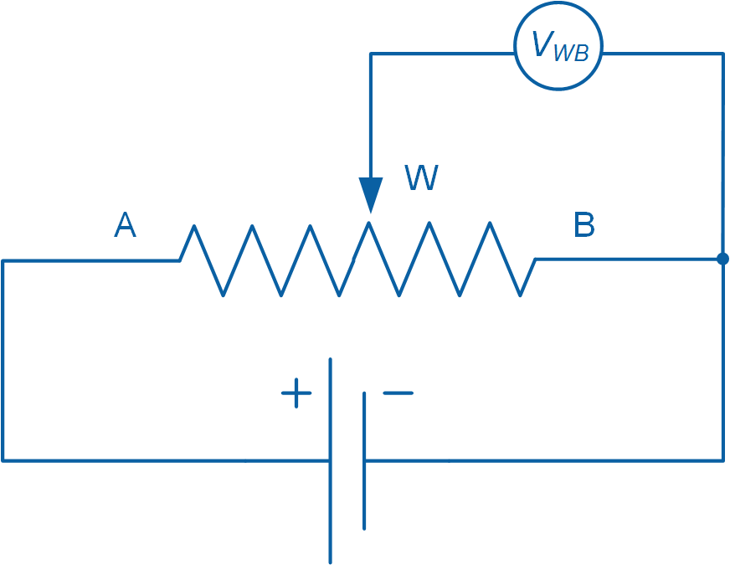

Figure 1-3: Schematic diagram of the voltage dividing characteristic of a rotary potentiometer

Depending on their construction, some pots have physical stops which prevent the shaft from a full 360° rotation. To counter this limitation, pots that do not have physical stops are used when continuous rotational movement is desired. Another limitation is the presence of a dead-band, which occurs when the pot shaft is turned but the resistance stays the same. In continuous rotation potentiometers, dead-band occurs at the limits of the pot and results in a discontinuity in the output when used for angular displacement measurement.

The typical lifespan of a pot is a few thousand rotations. This is because the wiper makes physical contact with the resistive element inside the pot, eventually wearing it out. This physical contact and the presence of dust also causes both mechanical and electrical noise. While the mechanical noise is rather inaudible in modern pots, electrical noise causes variations in the measured output. In audio applications where pots are used for volume and tone control, the electrical noise manifests itself in the form of audible pops and crackles.

### 1.2 Implement

The Virtual Instrument (VI) used to collect data from and calibrate the potentiometer is shown in Figure 1-4.

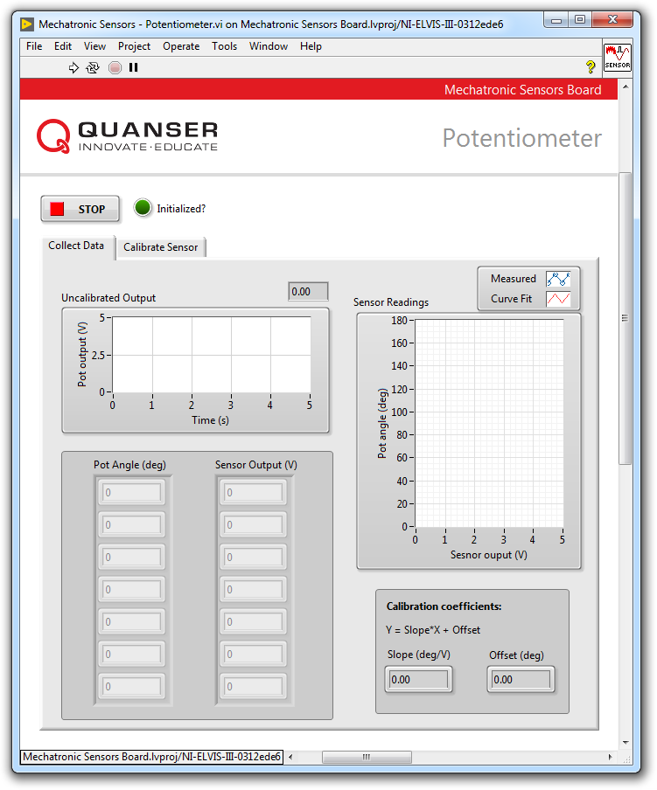

Figure 1-4: VI for collecting data from the potentiometer

#### Collect Data

1. Open **Mechatronic Sensors Board.lvproj**
2. From the **Project Explorer** window, open **Mechatronic Sensors - Potentiometer.vi**
3. Click on the **Collect Data** tab.
4. Run the VI.
5. Wait for the **Initialized?** LED indicator to turn on.
6. Set the potentiometer knob to the 0° mark.
7. Enter 0 in the **Pot Angle (deg)** array.
8. Using the **Uncalibrated Output** waveform chart, read the corresponding sensor output and enter the value in the **Sensor Output (V)** array.
9. Continue taking measurements by rotating the potentiometer at 30° intervals. Enter the angular position and measured sensor outputs in the **Pot Angle (deg)** and **Sensor Output (V)** arrays respectively. Take a screenshot of your results.  
     
   Note: Once all of the measured data have been entered, a linear curve is automatically generated to fit the data. The curve is shown in the **Sensor Readings** waveform graph. This curve represents the calibration curve of the sensor.
10. The slope and offset of the calibration curve are automatically calculated by the VI and displayed in the **Slope (deg/V)** and **Offset (deg)** indicators. Make a note of these values.
11. Record the collected data in Table 1-1.
12. Take a screenshot of the **Sensor Readings** graph.
13. Continue to the next section.

Table 1-1: Recorded potentiometer measurements

|  |  |
| --- | --- |
| Angle (deg) | Output (V) |
| 0° |  |
| 30° |  |
| 60° |  |
| 90° |  |
| 120° |  |
| 150° |  |
| 180° |  |

#### Calibrate the Potentiometer

1. Click on the **Calibrate Sensor** tab to calibrate the output of the potentiometer in terms of angular position (in degrees).
2. Use the **Slope (deg/V)** and **Offset (deg)** numeric controls to enter the slope and offset values you obtained during the data collection step.
3. Test the accuracy of your calibration. To do this, set the potentiometer knob to different angles and verify that the correct angular position is displayed in the **Calibrated Output** waveform chart as well as the **Pot Angle (deg)** meter indicator.
4. Press the **Stop** button.

### 1.3 Analyze

1-1 Present the results you recorded in Table 1-1.

1-2 Attach a screenshot of the *Sensor Readings* waveform graph that shows the fitted calibration curve from step 12.

1-3 What was the calibration equation that you obtained?

1-4 What is the sensitivity of the sensor in mV/deg?

## Section 2: Measuring Angular Displacement using an Encoder

### 2.1 Theory and Background

#### What is an Encoder?

An incremental optical encoder, shown in Figure 2-1, is a relative angular displacement sensor which measures angular displacement relative to a previously known position. Unlike an absolute encoder, an incremental encoder does not retain its position information upon power loss. An incremental encoder outputs a series of pulses which correlate to the relative change in angular position. Encoders are commonly used to measure angular displacement of rotating load shafts. Information extracted from an incremental encoder can also be used to derive instantaneous rotational velocities.

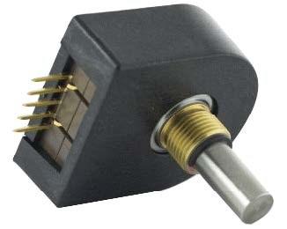

Figure 2-1: An incremental rotary encoder manufactured by US Digital

An incremental optical encoder typically consists of a coded disk, an Infrared (IR) LED, and two photosensors. The disk is coded with an alternating light and dark radial pattern causing it to act as a shutter. As shown schematically in Figure 2-2, the light emitted by the IR LED is interrupted by the coding as the disk rotates around its axis.

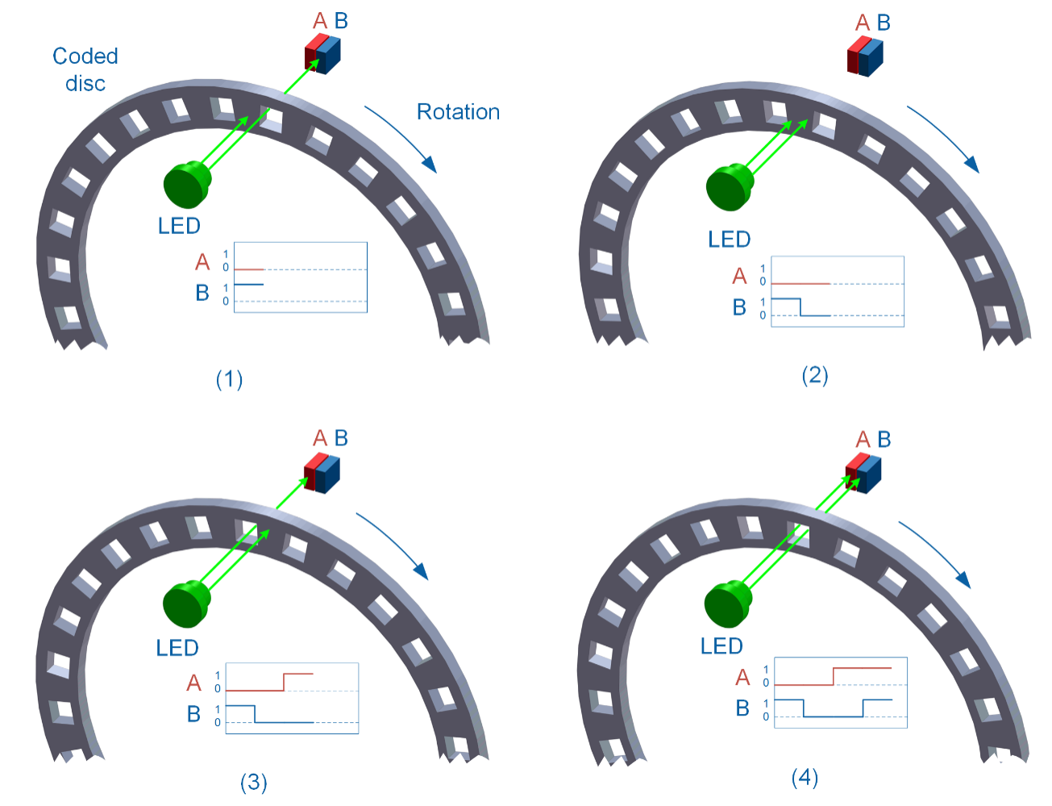

Figure 2-2: Output of an incremental encoder showing signals A and B when rotating in a clockwise manner

The two photosensors (A and B) positioned behind the coded disk sense the infrared light emitted by the IR LED, which results in A and B signals/pulses, in four distinct states as outlined in Table 2-1:

Table 2-1: Different quadrature states

|  |  |  |
| --- | --- | --- |
| State | Signal A | Signal B |
| 1 | OFF | ON |
| 2 | OFF | OFF |
| 3 | ON | OFF |
| 4 | ON | ON |

Encoders which output A and B signals are often referred to as quadrature encoders since the signals are separated in phase by 90° and result in four distinct states. Non-quadrature encoders have only one output signal and thus are unable to detect direction. The resolution of an encoder is determined using the number of light or dark patterns on the disk, a measure that is given in terms of *pulses per revolution*, or PPR.

Some encoders utilize an index pulse (Z channel), which is triggered once for every full rotation of the disk (see Figure 2-3). The index pulse can be used for calibration or so-called homing of a system, as well as a revolution counter. Depending on the encoder, the width of the index plus may be aligned with any of the four quadrature states. For example, the index pulse may have a width that spans a full cycle (4 states), a half cycle (2 states), or a quarter cycle (1 state). In the example shown in Figure 2-3, the width of the index pulse is aligned with a full cycle of the B signal.

There are two methods that an encoder registers the index pulse: (a) using pre-defined states of signals A and B, or (b) using user-defined states of signals A and B, in which case the user must select a combination of A and B states that occurs only once during the width of the index pulse.

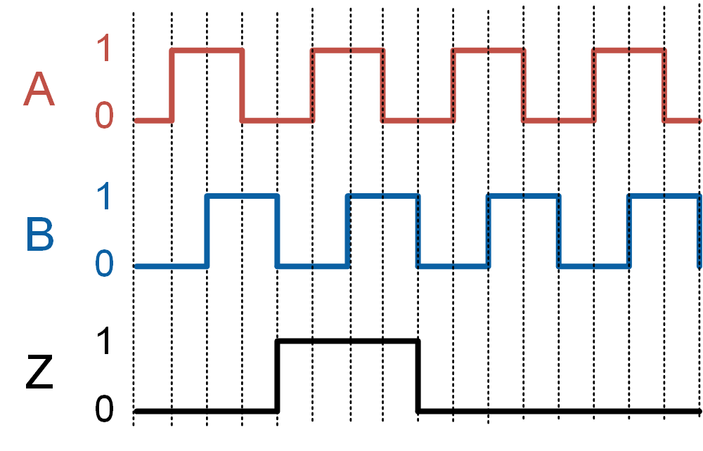

Figure 2-3: Output of a quadrature encoder with an index pulse

#### Encoder Decoding

In order to make encoder measurements, you need to connect the encoder outputs to a counter. A decoding algorithm is then used to determine the number of counts and possibly the direction of rotation.

Four common decoding algorithms are used: non-quadrature, X1, X2, and X4.

##### Non-quadrature

When a non-quadrature decoder is used, only the rising edge of signal A is counted as the shaft rotates. The counter is incremented on the rising edge of signal A. Because signal B is not used, the encoder cannot detect the direction of rotation. For example, using a non-quadrature decoder, a 9 PPR encoder will result in a total of 9 counts for every rotation of the encoder shaft. The count will increase regardless of which direction the shaft is rotated.

##### X1 Decoder

When an X1 decoder is used, only the rising edge of signal A is counted as the shaft rotates. When a rising edge of signal A occurs, the algorithm looks at the current state of signal B. If signal B is low, the counter is incremented. Otherwise, when signal B is high, the counter is decremented. Using an X1 decoder, a 9 PPR encoder will result in a total of 9 counts for every rotation of the encoder shaft.

##### X2 Decoder

When an X2 decoder is used, both the rising and falling edges of signal A are counted as the shaft rotates. When a rising edge of signal A occurs, the algorithm looks at the current state of signal B. If signal B is low, the counter is incremented. Otherwise, when signal B is high, the counter is decremented. When a falling edge of signal A occurs, if signal B is high the counter is incremented, otherwise when signal B is low the counter is decremented. Using an X2 decoder, a 9 PPR encoder will generate a total of 18 counts for every rotation of the encoder shaft.

##### X4 Decoder

When an X4 algorithm is used, both the rising and falling edges of both signals A and B are counted. Using a state machine diagram, Figure 2-4 illustrates how the counter is incremented or decremented depending on the state of signals A and B. An X4 decoder generates four times the number of counts generated by an X1 decoder resulting in the highest resolution among the three types of decoders. Using an X4 decoder, a 9 PPR encoder will generate a total of 36 counts for every rotation of the encoder shaft.

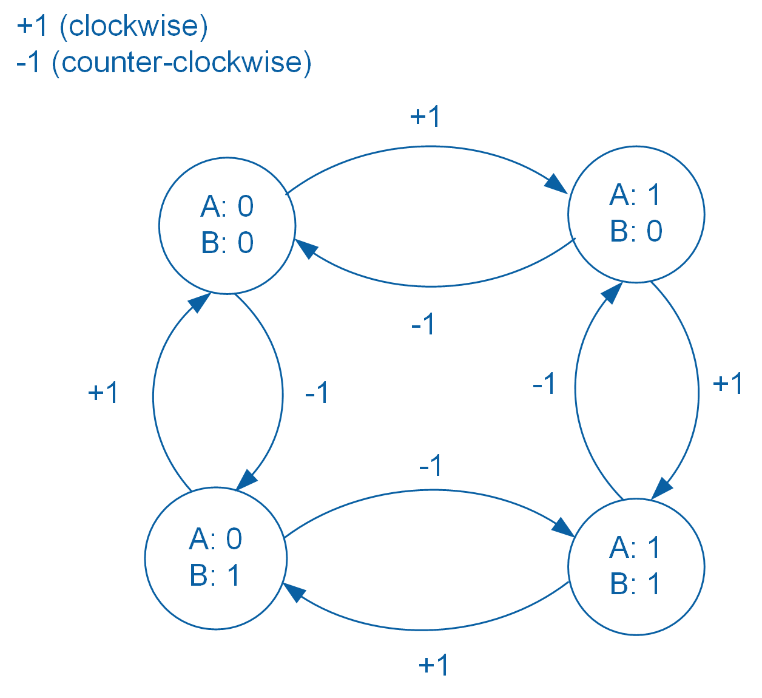

Figure 2-4: State machine representation of the X4 decoding algorithm

#### Measuring Angular Displacement

Pulses generated by an encoder can be converted to angular position (in degrees) using Equation 2-1:

Equation 2-1

$$θ=\frac{Counts}{N∙PPR}∙360°$$

where *Counts* is the number of acquired edge counts, *N* = 1, 2, or 4 corresponds to non-quadrature/X1, X2, and X4 decoders respectively, and PPR is the encoder’s PPR value.

The angular resolution of an encoder (not to be confused with encoder resolution, or PPR) depends on the encoder’s *PPR* and the decoding algorithm used, and can be calculated using Equation 2-2:

Equation 2-2

$$∆θ=\frac{360°}{N∙PPR}$$

Figure 2-5 compares the number of counts generated by each of the non-quadrature, X1, X2, and X4 decoders.

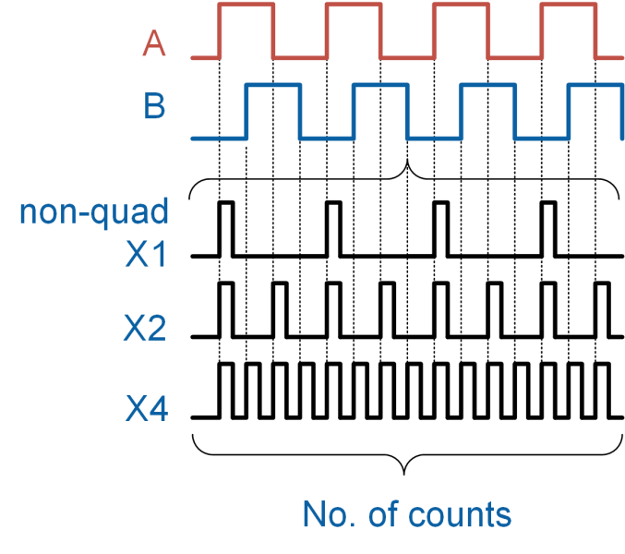

Figure 2-5: Comparison of the number of counts generated by different decoding algorithms

### 2.2 Implement

The Virtual Instrument (VI) used to collect data from and calibrate the encoder is shown in Figure 2-6.

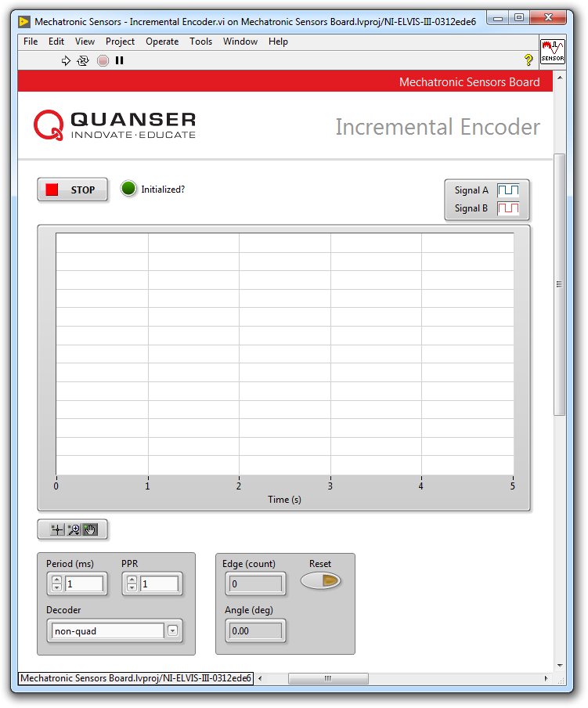

Figure 2-6: VI for collecting data from the encoder

#### Non-quadrature Decoding

1. Open **Mechatronic Sensors Board.lvproj**
2. From the **Project Explorer** window, open **Mechatronic Sensors - Incremental Encoder.vi**
3. From the **Decoder** drop-down menu, select **non-quad**.
4. Run the VI.
5. Wait for the **Initialized?** LED indicator to turn on.
6. In non-quadrature decoding only signal A is used. Rotate the encoder knob in the clockwise direction. How does the **Edge (count)** numeric display change?
7. Rotate the knob in the counter-clockwise directions. How does the **Edge (count)** numeric display change?

*Note:* At any time you can press the *Reset* button to reset the counter. This will rest the **Edge (count)** and **Angle (deg)** numeric displays to zero.

1. Using the **Edge (count)** numeric display, determine the number of pulses the encoder generates per each full revolution (PPR).

*Note:* PPR is determined in non-quadrature mode. It refers to the total number of pulses generated by *Signal A* when the encoder makes one full revolution. The value of PPR will be used to calibrate the encoder pulses in terms of angular displacement in degrees.

1. Continue to the next section.

#### Calibrate the Encoder

1. Calibrate the pulses of the encoder in terms of angular displacement. To do this, enter the PPR value which was calculated in the previous section in the **PPR** numeric control and press the **Enter** key.
2. Verify the accuracy of your calibration. To do this, first press the **Reset** button then rotate the encoder knob and verify that the correct angular position is displayed in the **Angle (deg)** numeric indicator.
3. Continue to the next section.

#### X2 Decoding

1. From the **Decoder** drop-down menu, select **X2**.
2. Press the **Reset** button.
3. In X2 decoding both signals A and B are used. Rotate the encoder knob in the clockwise direction. How do the **Edge (count)** and **Angle (deg)** numeric displays change?  
     
   *Note:* An encoder will have a fixed PPR value regardless of the decoding algorithm that is used.
4. Rotate the knob in the counter-clockwise direction. How do the **Edge (count)** and **Angle (deg)** numeric displays change?
5. Examine the behavior of signal A and signal B.
6. What is the resolution of the measured angular displacement?
7. Continue to the next section.

#### X4 Decoding

1. From the **Decoder** drop-down menu, select **X4**.
2. Press the **Reset** button.
3. Rotate the knob in the clockwise and counter-clockwise directions. How do the **Edge (counts)** and **Angle (deg)** numeric displays change?
4. What is the resolution of the measured angular displacement?
5. Examine the behavior of signal A and signal B as you slowly rotate the encoder knob in the clockwise direction. In particular, compare the behavior of signals A and B and you rotate the encoder in the clockwise direction with the state machine diagram shown in Figure 2-4. Take a screenshot of your results.
6. Press the **Stop** button.

### 2.3 Analyze

2-1 How did the Edge (count) numeric display change when the knob was rotated in the clockwise direction in step 6?

2-2 How did the Edge (count) numeric display change when the knob was rotated in the counter-clockwise direction in step 7? Explain the observed behavior.

2-3 What is the PPR of the sensor that you calculated in step 8?

2-4 When using non-quadrature decoding, as the encoder knob was rotated in step11, did the Angle (deg) numeric indicator display the correct angular position?

2-5 When using X2 decoding, as you rotated the encoder knob in step 15, how did the Edge (count) and Angle (deg) numeric displays change?

2-6 As you rotated the encoder knob in the counter-clockwise directions in step 16, how did the Edge (count) and Angle (deg) numeric displays change? Explain the observed behavior.

2-7 What is the resolution of the measured angular displacement that you calculated in step 18? Does it match the expected angular resolution using Equation 2-2?

2-8 When using X4 decoding, as you rotated the encoder knob in the clockwise and counter-clockwise directions in step 22, how did the Edge (counts) and Angle (deg) numeric displays change?

2-9 What is the resolution of the measured angular displacement that you calculated in step 23? Does it match the expected angular resolution using Equation 2-2?

2-10 Compare the angular resolutions of the X2 and X4 decoding.

2-11 Using the screenshot you captured in step 24, compare the behavior of signals A and B and you rotate the encoder in the clockwise direction with the state machine diagram shown in Figure 2-4. Do your results match the state machine sequence?

## Section 3: Design Considerations

3-1 You are tasked to select an incremental encoder for measuring the position of a DC motor. You require a minimum resolution of 0.01 radians. Furthermore, your data acquisition system (DAQ) and software can only perform X2 decoding. What is the minimum PPR required to meet this design constraint?

3-2 As noted in the background section, a counter is used to count the pulses generated by an encoder. Counters are specified using a bit size. For example, a 24-bit counter is capable of counting up to 224 = 16,777,216 counts. When a counter exceeds its counting ability, it will wrap or overflow.

Assume that you have a 1,000 PPR encoder and a 24-bit counter at your disposal. You plan to use the encoder to monitor the rotational velocity of a shaft that rotates at a maximum speed of 500 rpm. Your DAQ performs X4 decoding. Calculate the minimum duration that the counter can monitor the shaft’s speed before it overflows.

3-3 Sampling data at an appropriate rate is required for making accurate measurements. Sample rate or sample frequency is the rate at which a DAQ reads or digitizes an input signal. The unit of sample rate is hertz, or samples per second. The sample rate is often defined by the user, although each DAQ will have limitations on how fast it can acquire data. One can think of DAQ sampling as snapshots, similar to the frames of a movie. The faster a DAQ samples a real signal, the greater the resolution and detail that can be seen in the digitized signal.

Figure 2-7 shows the effect of different sampling rates when acquiring a sinusoidal signal. As illustrated by the figure, sampling at different rates will result in different digitized waveforms. As sampling rate is increased, the resulting digitized sample more accurately resembles the true shape of the original signal.

Examine the effect of a low sampling rate on angular displacement measurement using the encoder. To do this, stop your VI using the **Stop** button. The default sampling period in the VI is set to 1 ms (equivalent to a sampling rate of 1,000 Hz). Change the sampling period to **20 ms** (equivalent to a sampling rate of 50 Hz). Select **X4** decoding and set the PPR numeric control to the value you determined earlier in this lab. Re-run the VI. Press the **Reset** button. Now slowly rotate the encoder shaft 360 degrees in the clockwise direction. The **Angle (deg)** numeric display should indicate an angular displacement of approximately 360 degrees. Reset the encoder again but this time, very quickly, rotate the encoder shaft 360 degrees in the clockwise direction. What value does the **Angle (deg)** numeric display indicate? Explain your results.

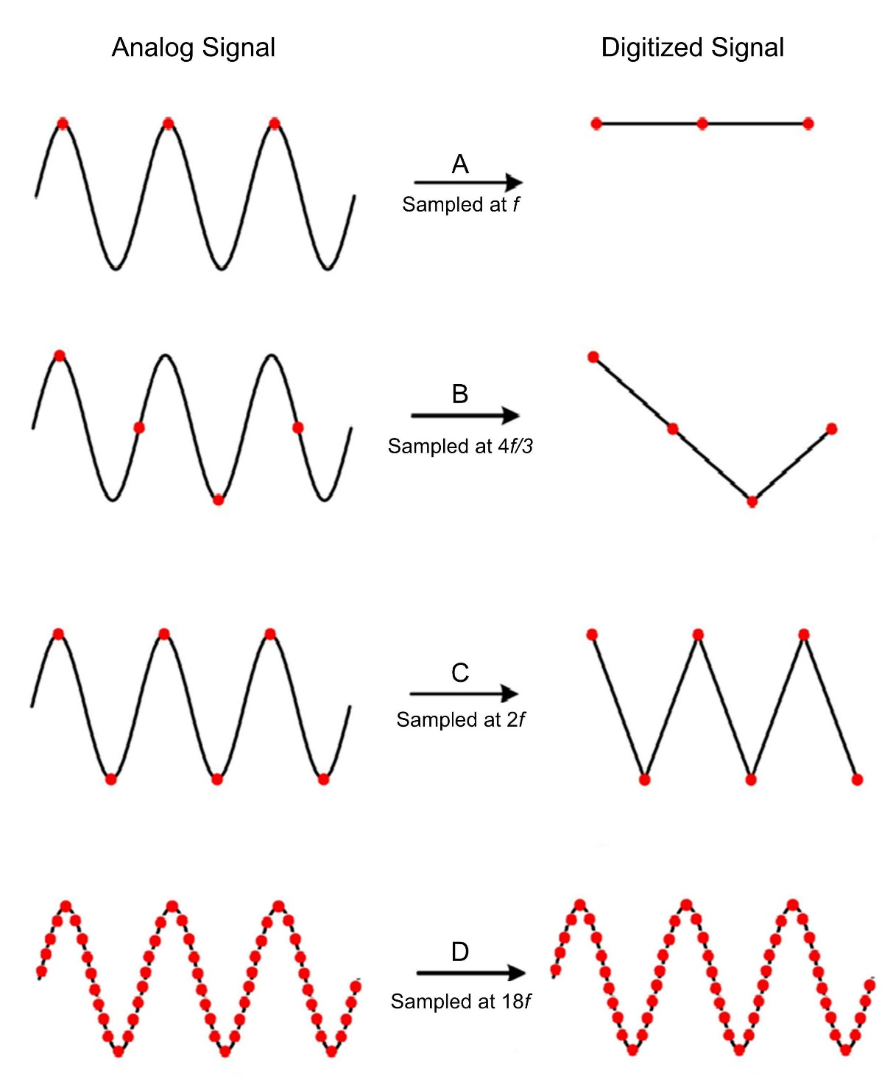

Figure 2-7: Effect of sample rate on an acquired sinusoidal signal

# Lab 2: Distance and Proximity

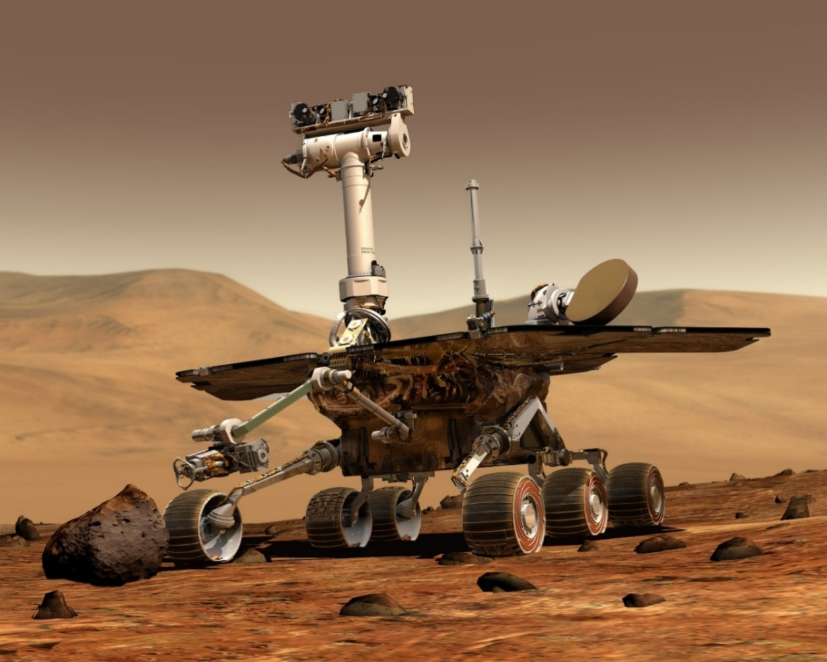

Figure 0: Distance measurement is an integral part of mobile robotic applications

This lab explores long-range distance measurement using a sonar, mid- to short-range distance measurement using a Time-of-Flight (ToF) sensor, as well proximity measurement using an infrared proximity sensor. Sensor calibration, measurement scatter, as well as the effect of target reflectivity, will be examined.

## Learning Objectives

After completing this lab, you should be able to complete the following activities:

* Calibrate the output of a sonar in terms of distance
* Characterize Time-of-Flight sensor scatter
* Determine sensor resolution
* Measure target proximity using an infrared proximity sensor
* Examine the effect of target reflectivity on the sensor output

## Required Tools and Technology

|  |  |
| --- | --- |
| Platform: NI ELVIS III | * View User Manual   http://www.ni.com/en-us/support/model.ni-elvis-iii.html |
| Hardware: Quanser Mechatronic Sensors Board | * View User Manual   http://www.ni.com/en-us/support/model.quanser-mechatronic-sensors-board-for-ni-elvis-iii.html |
| Software: LabVIEW Version 18.0 or Later  Toolkits and Modules:   * LabVIEW Real-Time Module * NI ELVIS III Toolkit | * Before downloading and installing software, refer to your professor or lab manager for information on your lab’s software licenses and infrastructure * Download & Install for NI ELVIS III * <http://www.ni.com/academic/download> * View Tutorials * http://www.ni.com/academic/students/learn-labview/ |
| Accessories:  * Sturdy 12 in by 12 in cardboard (white color) * Sturdy 12 in by 12 in cardboard (black color) | |

## Expected Deliverables

In this lab, you will collect the following deliverables:

* Record calibrated sonar data
* Screenshot of sonar calibration curve
* Record sonar calibration coefficients
* Calculate sonar resolution
* Calculate sonar sensitivity
* Record ToF sensor scatter data
* Screenshot of ToF scatter behavior
* Calculate the standard deviation of ToF sensor scatter data
* Record proximity sensor threshold data
* Plot curve relating proximity sensor pulse count to a proximity threshold
* Examine the effect of target reflectivity on proximity threshold
* Experimental plan to compare sonar, ToF, and proximity sensors for distance measurement

Your instructor may expect you to complete a lab report. Refer to your instructor for specific requirements or templates.

## Section 1: Measuring Long-range Distance using a Sonar

### 1.1 Theory and Background

#### What is a Sonar?

A sonar is a sensor that uses the propagation of ultrasonic waves to detect objects. Figure 1-1 shows an integrated sonar distance sensor. The sensor consists of an ultrasonic transmitter, receiver, and signal conditioning circuitry.

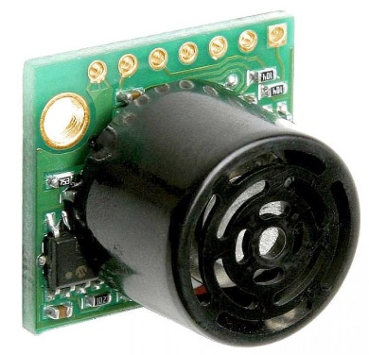

Figure 1-1: The MaxBotix sonar sensor used in the Quanser Mechatronic Sensors Board

As illustrated in Figure 1-2, the transmitter generates a spherical cone-shaped ultrasonic pulse or ping which, when reflected off a nearby object, is picked up the receiver. The signal conditioning circuit measures the time it takes for the ultrasonic ping to travel to the object, bounce off, and be picked up by the receiver. Since sound waves travel at a constant speed (343 m/s in dry air at 20 °C), the speed of the transmitted and reflected ping will be the same, and hence the distance, *d*, from the reflecting object can be determined using Equation 1-1:

Equation 1-1

$$d=\frac{1}{2}c∙t$$

Where *d* is the distance between the sensor and the reflecting object, *c* is the speed of sound, and *t* is the time it takes for the transmitted ultrasonic ping to travel from the transmitter back to the receiver. Sonars typically generate several synchronized ultrasonic pings per second.

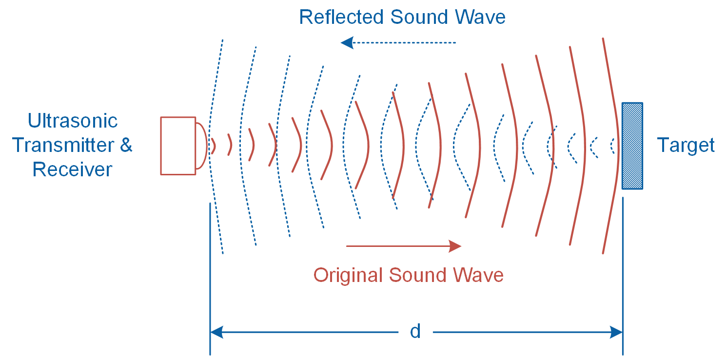

Figure 1-2: Sonar technique transmits and receives ultrasonic pings

Sonar distance sensors are ideal for long-range distance measurements as well as detecting large objects. The sensor mounted on the Quanser Mechatronic Sensors Board can measure objects ranging from 6 to 254 inches with a resolution of ±1 inch. Prior to being measured by the data acquisition system, the signal generated by the sonar is amplified using the non-inverting amplifier illustrated in Figure 1-3. The relationship between the input and output voltages of the amplifier is determined using Equation 1-2:

Equation 1-2

$$V_{O}=\left(1+\frac{R_{2}}{R_{1}}\right)V_{in}$$

Where *Vin* is the signal generated by the sonar sensor, *VO* is the amplified signal, and resistors *R1* = 10 k and *R2* = 10 k determine the gain of the amplifier as follows: *G* = 1 + *R2*/ *R1.*

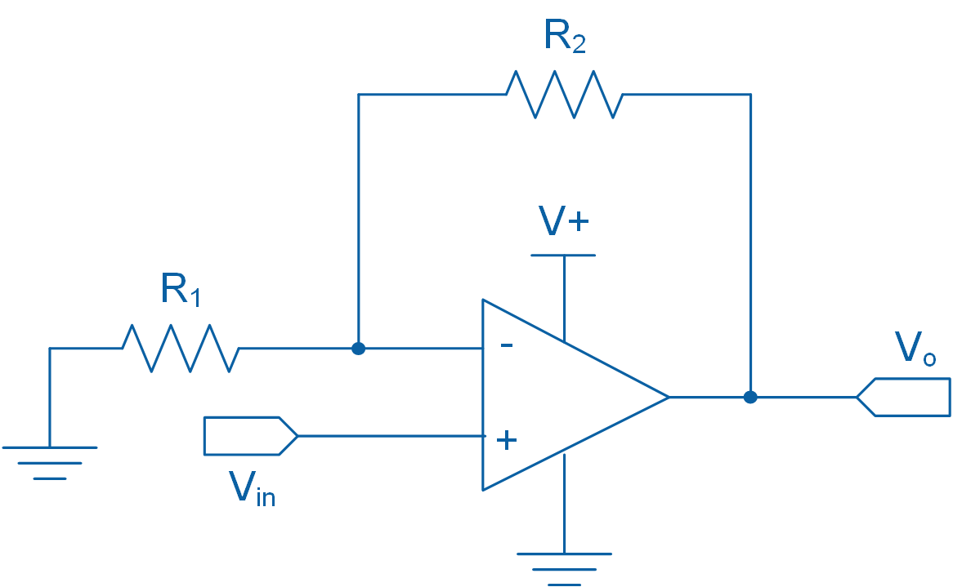

Figure 1-3: Non-inverting amplifier circuit diagram

In general, sonar sensors are not suitable for close-range measurements and their resolution is relatively coarse. Furthermore, they may not detect soft objects such as clothing, blankets, and porous materials. Since the sonar technique relies on measuring reflected ultrasonic sound waves, sonar does not work in space.

### 1.2 Implement

The Virtual Instrument (VI) used to collect data from and calibrate the sonar is shown in Figure 1-4.

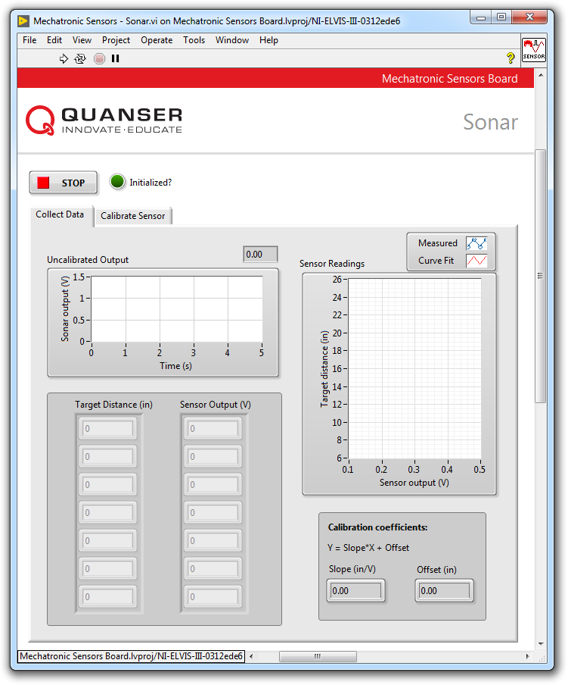

Figure 1-4 VI for collecting data from the sonar

#### Collect Data

1. Prior to conducting this lab, use the **Application Board Power** switch to cycle the Quanser Mechatronic Sensors Board power. The MaxBotix sonar sensor performs a self-calibration on power-up to compensate for ambient temperature and humidity. Ensure that there are no objects close to the sensor while cycling the power. Best sensitivity is obtained when the sensor’s detection area is clear of any objects for 14 inches during power-up.
2. Open **Mechatronic Sensors Board.lvproj**
3. From the **Project Explorer** window, open **Mechatronic Sensors - Sonar.vi**
4. Click on the **Collect Data** tab.
5. Run the VI.
6. Wait for the **Initialized?** LED indicator to turn on.
7. Enter **7** in the **Target Distance (in)** array.
8. Hold a sturdy cardboard target that is sized 12 in by 12 in at a distance of 7 inches away from the surface of the application board. Using the **Uncalibrated Output** waveform chart, read the corresponding sensor output and enter the value in the **Sensor Output (V)** array.  
     
   *Note:* Since the sensor generates a wide cone-shaped pulse, do not stand too close to the sensor while taking measurements. It will cause the sensor to detect your body which will interfere with your measurements. When measuring targets at longer distances, you will need to stand back and stretch out your arm while holding the target to get a valid measurement.
9. Continue taking measurements by moving the target in 3 inch intervals away from the sensor. Each time, enter the target distance and measured sensor outputs in the **Target Distance (in)** and **Sensor Output (V)** arrays respectively.  
     
   *Note*: Once the measured readings are entered, a linear curve is automatically generated to fit the data. The curve is shown in the **Sensor Readings** waveform graph. This curve represents the calibration curve of the sensor.
10. Record the collected data in Table 1-1.
11. The slope and offset of the calibration curve are automatically calculated by the VI and displayed in the **Slope (in/V)** and **Offset (in)** indicators. Record these values in Table 1-2.
12. Take a screenshot of the **Sensor Readings** graph.
13. Continue to the next section.

Table 1-1 Recorded sonar measurements

|  |  |
| --- | --- |
| Target Distance (in) | Sensor Output (V) |
| 7 |  |
| 10 |  |
| 13 |  |
| 16 |  |
| 19 |  |
| 22 |  |
| 25 |  |

Table1-2: Calibration coefficients

|  |  |
| --- | --- |
| Slope (in/V) | Offset (in) |
|  |  |

#### Calibrate the Sonar

1. Click on the **Calibrate Sensor** tab to calibrate the output of the sonar in terms of linear displacement of the target (in inches).
2. Use the **Slope (in/V)** and **Offset (in)** numeric controls to enter the slope and offset values you obtained during the data collection process.
3. Test the accuracy of your calibration. To do this, place the target at different known positions within the calibrated range, and verify that the correct distance is displayed in the **Calibrated Output** waveform chart as well as the **Distance (in)** slider indicator.
4. Using the **Calibrated Output** waveform chart, approximate the resolution of the sensor (in inches). Start by holding the target 7 inches away from the sensor. At a steady rate, slowly move the target away from the sensor and observe its response. The calibrated output of the sensor will have a step-like response. What is the smallest change in distance that it can detect? Take a screenshot of the response of the sensor. Compare your result with the resolution of the sensor provided in Section 1.1.
5. Press the **Stop** button.

### 1.3 Analyze

1-1 Present the results you recorded in Table 1-1.

1-2 Attach the screenshot of the Sensor Readings waveform graph showing the fitted calibration curve from Step 12.

1-3 Present the calibration coefficients that you recorded in Table 1-2.

1-5 What is the resolution of the sonar that you determined in Step 17? Compare your result with the resolution of the sensor provided in Section 1.1. Attach the screenshot of the step-like response of the sensor.

1-6 As noted in Section 1.1, the Quanser Mechatronic Sensors Board implements the non-inverting amplifier circuit shown in Figure 1-3. Using Equation 1-2 and the calibration coefficients recorded in Table 1-2, calculate the sensitivity of the sensor in terms of V/in? Assume R1 = R2 = 10 k.

## Section 2: Measuring Short to Mid-range Distance using a Time-of-Flight Sensor

### 2.1 Theory and Background

#### What is a Time-of-Flight Sensor?

A Time-of-Flight (ToF) sensor, pictured in Figure 2-1, uses the Time-of-Flight principle to measure short to mid-range distances. Time-of-Flight is a measurement technique used for measuring the distance between a sensor and a target, based on the time difference between the emission of a signal and its return to the sensor when reflected by the target. ToF sensors typically have a small footprint (several millimeters) and measure short to medium distances ranging from 100 mm to 2,000 mm. Most ToF sensors are digital sensors, which means communication with the sensors is achieved using SPI or I2C protocols.

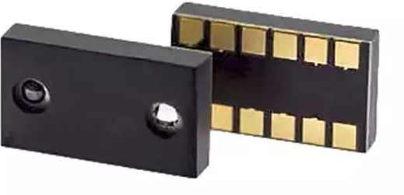

Figure 2-1: A ToF sensor manufactured by RF Digital Corporation

As illustrated in Figure 2-2, a ToF sensor contains an infrared LED or low-power laser source. At regular intervals, the sensor pulses the light source. Each time the light source bounces off an object, the built-in receiver measures the “time-of-flight”, or how long it has taken for the beam to travel to the target and bounce back onto the receiver. The target distance can be determined using Equation 2-1:

Equation 2-1

$${d=\frac{1}{2}t}_{d}∙c$$

where *d* is the measured target distance in meters, *td* is the time for the bounced beam to be detected by the receiver in seconds, and *c* is the speed of light in meters per seconds. For example, assuming *c* = 300,000,000 m/s, for an object located 2 meters away from the sensor, it takes approximately 13 nanoseconds for the pulsed beam to travel from the source to the receiver.

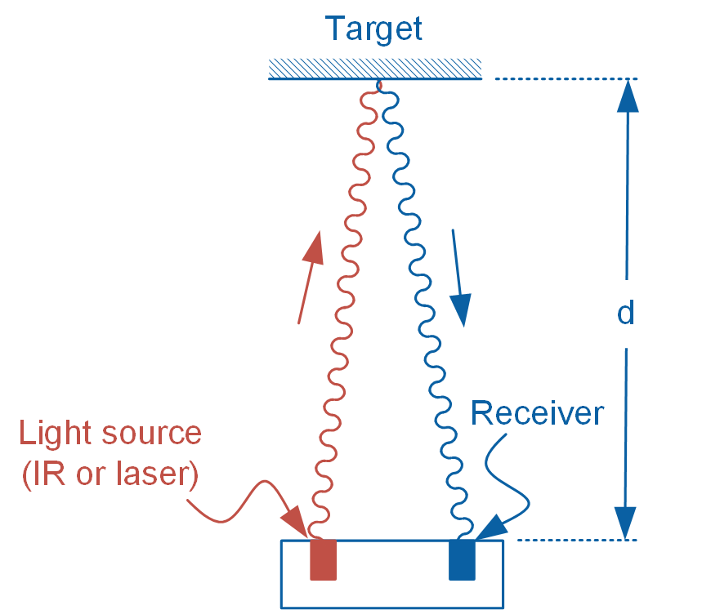

Figure 2-2: The principle of ToF

Since ToF technology uses light rather than a sonic pulse to detect objects, unlike a sonar, it can operate in vacuum. ToF sensors are widely used in robotics and consumer electronic goods. In robotic applications, for example, ToF sensors are used for obstacle detection and avoidance. White goods type of applications include hand detection in automatic faucets and soap dispensers. More advanced applications include gesture recognition, directional movement detection and volume or height control.

When designing a ToF measurement system, it is important to consider how environmental conditions may impact your measurements. For example, since ToF sensors typically contain an infrared light source, the presence of other light sources that contain a rich infrared component, such as a halogen light bulb, may cause the sensor to output erroneous values.

### 2.2 Implement

The Virtual Instrument (VI) used to collect data from the ToF sensor is shown in Figure 2-3.

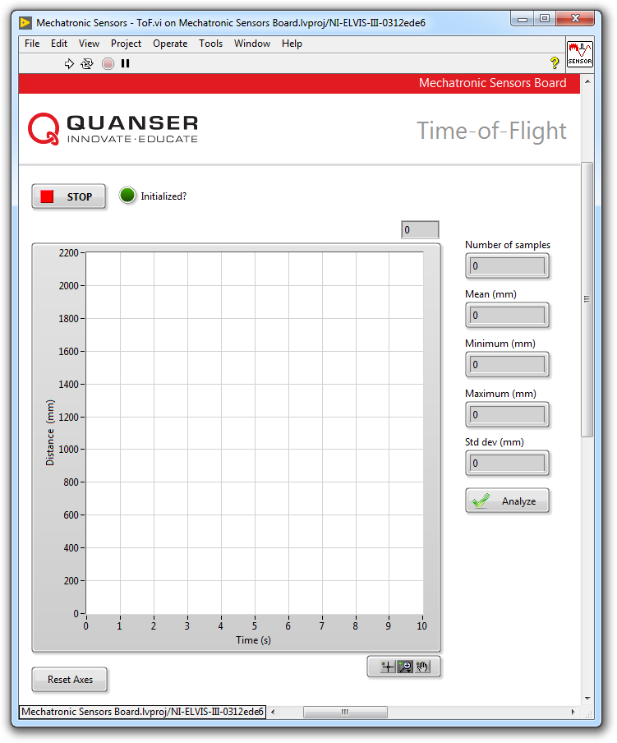

Figure 2-3: VI for collecting data from the ToF sensor

#### Observe Measurement Scatter

1. Open **Mechatronic Sensors Board.lvproj**
2. From the **Project Explorer** window, open **Mechatronic Sensors - ToF.vi**
3. Run the VI.
4. Wait for the **Initialized?** LED indicator to turn on.
5. The Quanser Mechatronic Sensors Board’s digital ToF sensor outputs an 11-bit value ranging between 0 and 2048, which directly corresponds to the target distance in millimeters. As such, you do not need to calibrate the output of the sensor in terms of measured distance.  
     
   However, the output of the ToF sensor exhibits random variation, or scatter, as shown in Figure 2-4. Observe this scatter by holding a sturdy cardboard target that is sized 12 in by 12 in at various random positions ranging between 100 mm and 1000 mm. Takes screenshots of your observations. Does the level of scatter change with target distance?  
   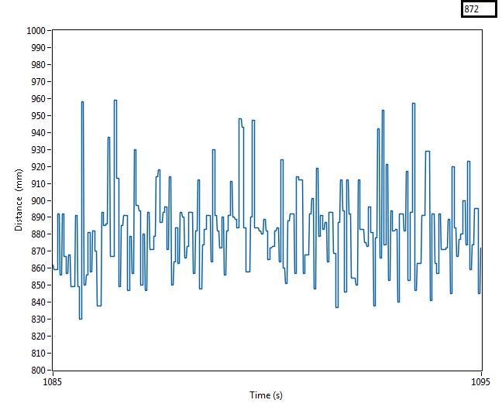

Figure 2-4 Measurement scatter associated with the output of the ToF sensor

#### Quantify Measurement Scatter

1. Quantify the level of measurement scatter. To do this, steadily hold the target at an approximate distance of 100 mm from the ToF sensor. Wait for the readings to stabilize for at least **3 seconds,** and then click the **Analyze** button. The VI is programmed to collect 300 data points at a rate of 100 Hz. When the *Analyze* button is pressed, the VI calculates and displays the mean, minimum, maximum, and standard deviation of the acquired data. Record these values as your first trial in Table 2-1. Repeat the measurement twice more and record the data in Table 2-1.
2. Now repeat the previous step but this time hold the target at a distance of approximately 1000 mm. Record your results in Table 2-1.
3. Press the **Stop** button.

Table 2-1: Scatter data

|  |  |  |  |  |  |
| --- | --- | --- | --- | --- | --- |
| Approx. distance (mm) | Trial | Mean  (mm) | Max  (mm) | Min  (mm) | Std Dev  (mm) |
| 100 | 1 |  |  |  |  |
| 2 |  |  |  |  |
| 3 |  |  |  |  |
| 1000 | 1 |  |  |  |  |
| 2 |  |  |  |  |
| 3 |  |  |  |  |

### 2.3 Analyze

2-1 Detail your observations of the output of the ToF sensor as the target is placed at different distances from the sensor (Step 5). What trend did you visually observe as the target is positioned further from the sensor? Attach screenshots of your results.

2-2 Present the results you recorded in Table 2-1.

2-3 Standard deviation is a statistical measure of the amount of variation, or scatter, within a set of measured data points. A larger standard deviation implies larger scatter within the acquired data. In this lab, since measurements for a given target distance were repeated multiple times, you must apply *pooled statistics* to provide a single best statistical estimate of the measured data.

For each target distance, calculate the *pooled standard deviation* using the data recorded in Table 2-1 and the formula below:

$$S_{pooled}=\sqrt{\frac{1}{N}\sum_{i=1}^{N}{S_{i}}}$$

where Spooled is the pooled standard deviation for a given target distance, N is the number of trials, and Si is the standard deviation of each trial. Compare the pooled standard deviations for the two different target positions. What do your results indicate about the scatter when the target is placed further away from the sensor?

## Section 3: Measuring Proximity using an Infrared Proximity Sensor

### 3.1 Theory and Background

#### What is an Infrared Proximity Sensor?

A typical reflective optical sensor is pictured in Figure 3-1. It consists of an infrared emitting diode (IRED) and a photodiode (detector). The emitting diode and detector are mounted side-by-side on parallel axes.

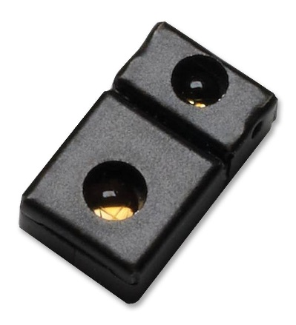

Figure 3-1: A digital proximity sensor manufactured by Broadcom Limited

When a surface is placed in the proximity of the sensor, the surface reflects the infrared light emitted by the IRED onto the photodiode. The further the surface is placed from the sensor, the less light is reflected onto the photodiode. The sensor will either output an analog signal that is proportional to the measured distance, or will output a digital equivalent of the measured distance.

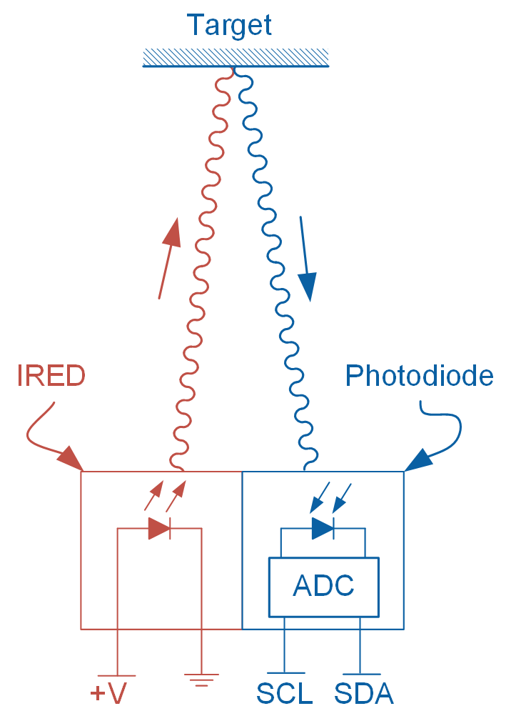

Figure 3-2: Schematic diagram of a digital proximity sensor

Figure 3-2 schematically illustrates the operation of a digital proximity sensor. When powered, the IRED emits pulsed infrared light, part of which is reflected by the reflective target onto the photodiode. A photodiode is a semiconductor that converts light photons to electrical current. The induced current is then converted to a digital signal (typically counts) by the built-in Analog-to-Digital (ADC) converter. In the illustrated example, the output of the ADC is read using the I2C protocol.

The Mechatronic Sensors Board uses a Broadcom APDS-9190 digital IR proximity sensor. The user can set the number of IRED pulses (between 1 and 255) generated by the sensor during each cycle of operation. Each pulse has a period of 16.3 s. A higher number of pulses increases the sensitivity of the sensor. The sensor outputs a count value ranging between 0 and 1023. The value depends on the distance of the target and is a measure of the amount of reflected IR light. A count value of 1023 means the target has reached the proximity detection threshold of the sensor. Once the output saturates at 1023 counts, it will not increase even if the target moves closer to the sensor.

Proximity sensors are typically used in near field proximity applications. For example, in mobile phones, the sensor can detect when the user positions the phone close to their ear.

### 3.2 Implement

The Virtual Instrument (VI) used to collect data from the IR proximity sensor is shown in Figure 3-3.

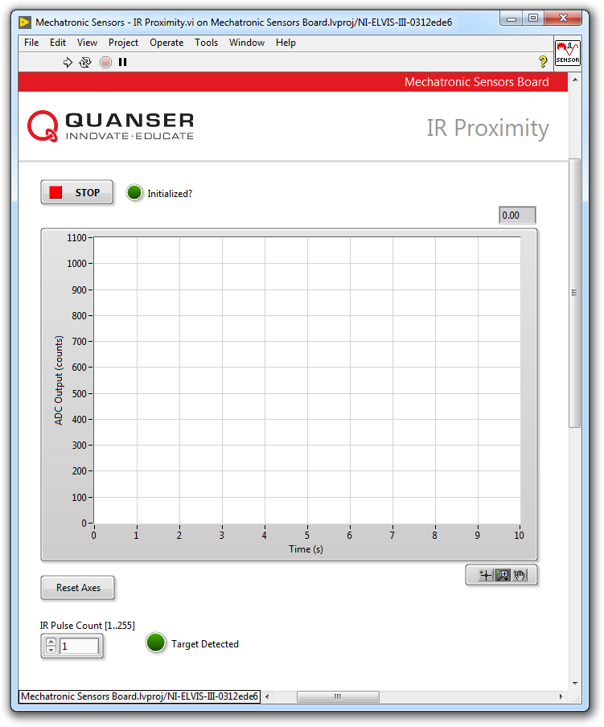

Figure 3-3: VI for collecting data from the IR proximity sensor

#### Observe Sensor Behavior

1. Open **Mechatronic Sensors Board.lvproj**
2. From the **Project Explorer** window, open **Mechatronic Sensors – IR Proximity.vi**
3. Run the VI.
4. Wait for the **Initialized?** LED indicator to turn on.
5. The waveform chart shows the raw count of the sensors analog-to-digital output.
6. Ensure the **IR Pulse Count [1..255]** numeric control is set to **1**. This setting causes the sensor to generate 1 IRED pulse during each cycle of operation.
7. Hold your hand at a distance of about 30 cm the sensor. Slowly move your hand toward the sensor and observe the response of the sensor; in particular, observe how the number of output counts increases as well as any scatter in the sensor’s output. Once your hand reaches the proximity threshold, the number of output counts will reach a maximum value of 1023. Using a ruler, estimate the threshold distance in terms of millimeters and record the value in Table 3-1. Take screenshots of your results.

Table 3-1: Sample recorded data

|  |  |
| --- | --- |
| IR Pulse Count | Proximity Threshold (mm) |
| 1 |  |
| 10 |  |
| 50 |  |
| 100 |  |
| 150 |  |
| 255 |  |

1. Stop the VI by pressing the **Stop** button.
2. As noted in section 3.1, a higher pulse count results in larger sensor sensitivity as well as a larger proximity threshold limit. To observe this, set **IR Pulse Count [1..255]** numeric control to **10** and re-run your VI and repeat step 7. Record your results in Table 3-1.
3. Repeat steps 8 through 9 for the remaining values of **IR Pulse Count** listed in Table 3-1.  
     
   *Note:* Prior to entering a new pulse count value, you must stop the VI each time. Enter a new value and re-run the VI.
4. Press the **Stop** button.

### 3.3 Analyze

3-1 Present the results you recorded in Table 3-1.

3-2 Detail your observations of the output of the IR proximity sensor as you moved your hand closer to the sensor for different pulse count values. Attach screenshots of your results.

3-3 Comment on the degree of scatter you observed for different IR pulse count values. Attach screenshots of your results.

3-4 Using the data recorded in Table 3-1, plot a curve that relates the sensor’s IRED pulse count to its proximity threshold. What type of curve best fits the data? Using this curve estimate the number of pulse count required to result in a proximity threshold of 70 mm. Run the VI and validate your results.

## Section 4: Design Considerations

4-1 You are asked to design a non-inverting amplifier for a sonar sensor similar to the one shown in Figure 1-3. The sensor has a sensitivity of 0.01 V/in and can measure a maximum distance of 254 in. At your disposal, you have a DAQ capable of measuring analog signals between 0 V and 10 V. Determine the maximum allowed gain of the circuit while satisfying the design constraints. Recommend appropriate values for the gain resistors R1 and R2.

4-2 Ideally, a proximity sensor must yield reproducible results regardless of the target color, surface texture, and surface reflectivity. In practice, however, IR proximity sensors are highly dependent on the ability of its target to reflect IR light. Examine and comment on the behavior of the IR proximity sensor that you used in Section2 using targets with different reflectivity. In particular, examine the effect of surface reflectivity on the proximity threshold. Use a white color cardboard and a black color cardboard as good and poor IR reflectors respectively. During your test set the **IR Pulse Count [1..255]** numeric control to **255**.

4-3 Devise an experimental plan to compare the performance and suitability of the sonar, ToF, and proximity sensors as distance sensors. Several key parameters to examine for each of the sensors include:

* Range
* Resolution
* Sensitivity
* Interface type (digital or analog)
* Target compatibility
  + Surface finish
  + Geometry
  + Color
* Operating environmental conditions
* Linearity

# Lab 3: Temperature

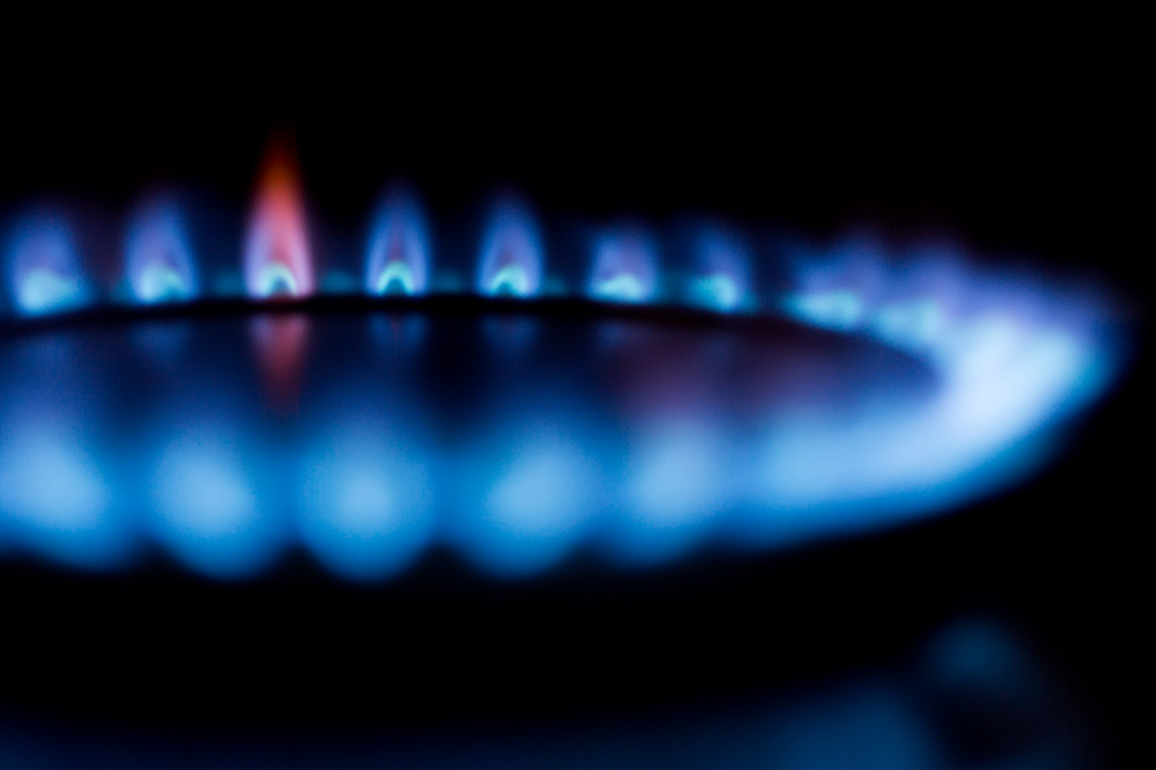

Figure 0: Many industries rely on the accurate measurement of temperature

This lab explores the thermo-resistive properties of a thermistor. A two-point calibration will be applied to the sensor and it thermal time-constant will be determined using a step input.

## Learning Objectives

After completing this lab, you should be able to complete the following activities:

* Apply a 2-point calibration to a thermistor
* Determine the -constant of a thermistor
* Apply a low-pass filter to the thermistor output
* Determine the thermal time-constant of a thermistor using a step input

## Required Tools and Technology

|  |  |
| --- | --- |
| Platform: NI ELVIS III | * View User Manual   http://www.ni.com/en-us/support/model.ni-elvis-iii.html |
| Hardware: Quanser Mechatronic Sensors Board | * View User Manual   http://www.ni.com/en-us/support/model.quanser-mechatronic-sensors-board-for-ni-elvis-iii.html |
| Software: LabVIEW Version 18.0 or Later  Toolkits and Modules:   * LabVIEW Real-Time Module * NI ELVIS III Toolkit | * Before downloading and installing software, refer to your professor or lab manager for information on your lab’s software licenses and infrastructure * Download & Install for NI ELVIS III * <http://www.ni.com/academic/download> * View Tutorials * http://www.ni.com/academic/students/learn-labview/ |
| Accessories:  * Thermometer * A small piece of clear tape |  |

## Expected Deliverables

In this lab, you will collect the following deliverables:

* Fingertip temperature measured using a thermometer
* Steady-state thermistor output when measuring fingertip temperature
* Calculate the resistance of the thermistor when measuring finger temperature
* Determine the -parameter of the thermistor
* Determine the thermal time constant of the thermistor under different conditions

Your instructor may expect you to complete a lab report. Refer to your instructor for specific requirements or templates.

## Section 1: Measuring Temperature using a Thermistor

### 1.1 Theory and Background

#### What is a Thermistor?

There are several different types of transducers available to measure temperature: thermocouple, resistance temperature detector (RTD), thermistor, and integrated circuit type. Each has their own advantages and disadvantages. Integrated circuit type sensors are low cost and have a linear output, but because they are mounted on a PCB they are board-layout dependent. Thermocouples have a wide temperature range, are relatively cheap, and are easy to use but are the least stable and sensitive. An RTD, on the other hand, is most stable and accurate of the sensors but is slow, has a fragile construction, and is relatively the most expensive. A thermistor responds very quickly, and has the highest sensitivity but has a limited temperature range. Figure 1-1 compares the typical sensitivity of the three temperature sensors.

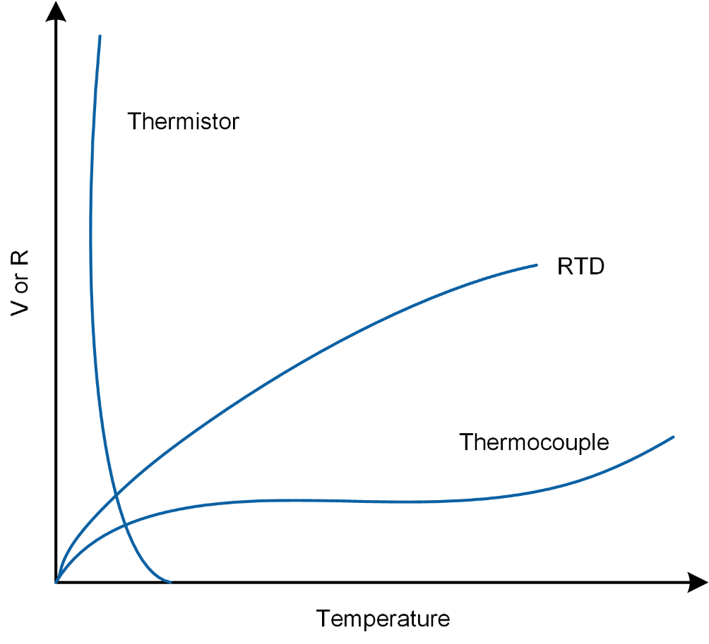

Figure 1-1: Comparison between the sensitivity of thermistors, RTD, and thermocouples

Thermistors differ from thermocouples in that they are resistive sensors with the latter being a voltage generating sensor. Because a current must be passed through a thermistor, it is susceptible to Ohmic heating. This self-heating manifests itself in the form of measurement error. Figure 1-2, illustrates various shapes of common thermistors.

|  |  |
| --- | --- |
| C:\Users\amolki\Desktop\QNET Mechatronic Sensors - Thermistor - Concept Review.jpg  (a) board-mount type | C:\Users\amolki\Desktop\QNET Mechatronic Sensors - Thermistor - Concept Review.jpg  (b) string type |

Figure 1-2: Different types of common thermistors manufactured by Murata

As a resistive sensor, the resistance of a thermistor is dependent on temperature. The relationship between the resistance of the thermistor, *RT*, and temperature, *T*, can be described using the -parameter equation:

Equation 1-1

$$R_{T}=R_{0}e^{β\left(\frac{1}{T}-\frac{1}{T_{0}}\right)}$$

where *R0* is the nominal resistance of the sensors at temperature *T0* in Kelvin, and  is a parameter which depends on the material, temperature, and construction of the thermistor and typically ranges between 3,500-4,700 K. For the thermistor on the Mechatronic Sensors board, the nominal sensor resistance is:

*R0* = 47,000 ohm

when the temperature is at 25 degrees Celsius or:

*T0 =* 298.15 K

The  -parameter equation provides an acceptable estimation of the measured temperature in applications that have a narrow temperature span (typically less than 20°C). The -parameter can be established using two temperature reference points.

A more accurate estimation temperature (±0.01°C over a 100°C span) can be made using the Steinhart-Hart equation as given in Equation 1-2:

Equation 1-2

$$\frac{1}{T}=A+B\ln{R_{T}}+C{\left(\ln{R_{T}}\right)}^{3}$$

where *A*, *B*, and *C* are the Steinhart-Hart parameters which are determined by means of a 3-point calibration process, and *RT* is the resistance of the thermistor at temperature *T* in Kelvin.

#### NTC and PTC Thermistors

Two types of thermistors are available: Negative Thermal Coefficient (NTC) and Positive Thermal Coefficient (PTC). The resistance of an NTC thermistor decreases with an increase in temperature. Conversely, the resistance of a PTC thermistor increases when the temperature increases. NTC thermistors are more sensitive compared to PTC thermistors, and therefore exhibit a much higher change in resistance when exposed to the same levels of temperature.

#### Measuring the Output of a Thermistor

Similar to most resistive sensors, the output of a thermistor is measured using a voltage dividing circuit. Figure 1-3 illustrates the voltage dividing circuit used in the Mechatronic Sensor board, where the thermistor is labeled as *RT*.

Using the voltage divider rule, the output voltage of the circuit shown in Figure 1-3 is by Equation 1-3:

Equation 1-3

$$v_{0}=\frac{5×47000}{47000+R_{T}}$$

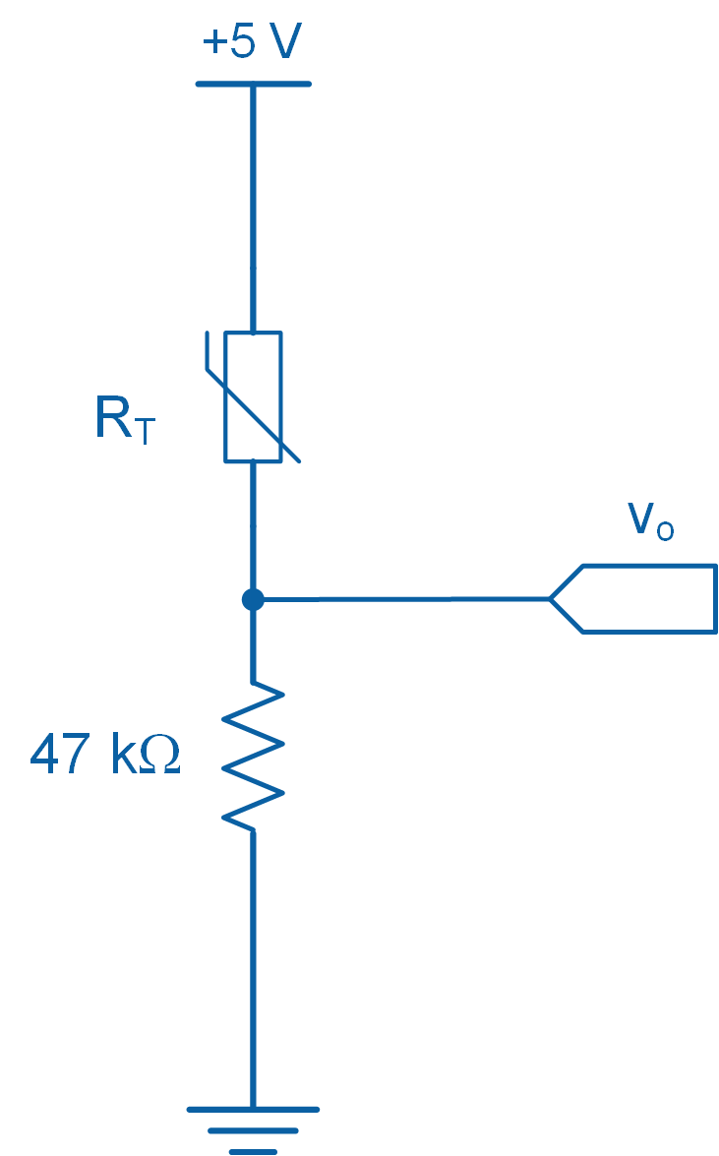

Figure 1-3: Thermistor circuit used in the Mechatronic Sensors board

#### Time Response of a Thermistor

Temperature sensors respond differently to changes in their input. For example, a liquid-filled bulb thermometer when taken outside on a cold winter day responds slowly to the change in temperature. In other words, the bulb thermometer does not instantaneously respond to a change in temperature. Time response is a measure of the time it takes for a sensor to respond to change. Typically sensors with fast response times are desirable.

#### Thermal Time Constant

Thermal time constant () is a measure of a sensor’s response to change and is defined as the time it takes for the sensor’s output to reach 63.2% (= 1-1/e*)* of the steady-state condition from an initial condition.

Figure 1-4, illustrates a typical time response curve. It shows how a sensor’s output behaves as it reaches steady-state. As shown in Figure 1-4, after one time constant () the system output reaches 63.2% of its steady-state value, after 2 time constants (2) the system reaches 86.5% of its steady-state value, and 95% is reached after 3 time constants (3). Theoretically, steady-state is achieved after infinite time, in practice, however, one waits until the output of the system or sensor is within an acceptable margin of error (typically 3 time constants). In thermal applications, time constants are typically large. Thermistors typically have a time constant of 0.5-4 seconds.

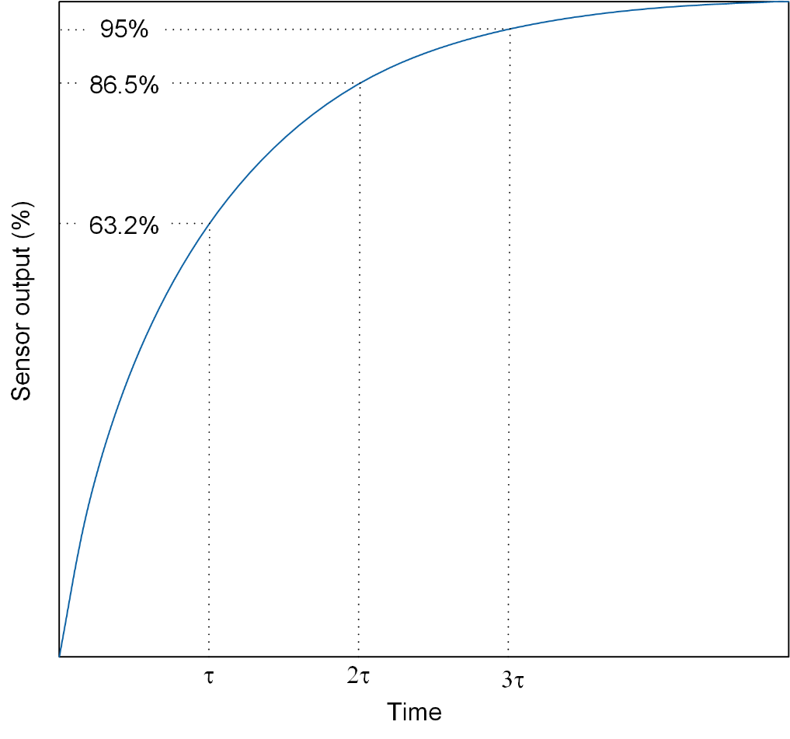

Figure 1-4: Time constant curve

### 1.2 Implement

The Virtual Instrument (VI) used to collect data from and calibrate the thermistor is shown in Figure 1-5.

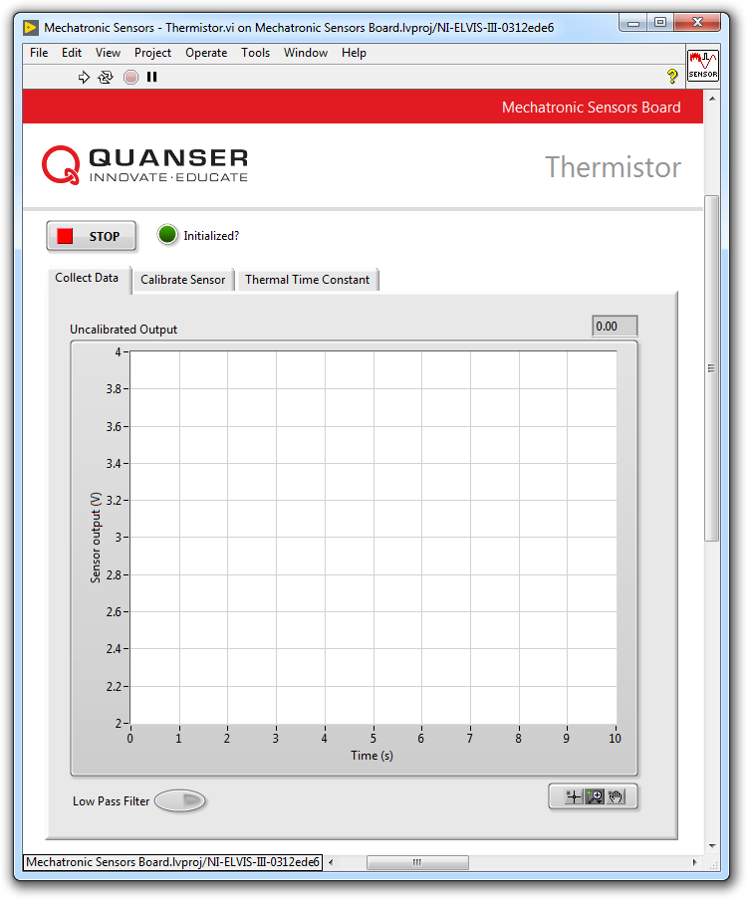

Figure1-5: VI for collecting data from the thermistor

#### Collect Data

1. Prior to starting this experiment, measure the temperature of your thumb using a thermometer and record the value in Table 1-1.  
     
   Note: In order to successfully conduct this experiment, your fingertip temperature must exceed 30 °C.
2. Open **Mechatronic Sensors Board.lvproj**
3. From the **Project Explorer** window, open **Mechatronic Sensors - Thermistor.vi**
4. Click on the **Collect Data** tab.
5. Run the VI.
6. Wait for the **Initialized?** LED indicator to turn on.
7. Gently place your fingertip on the thermistor and examine and take a screenshot of the response.  
     
   Note: If the output of the sensor is noisy, enable the **Low Pass Filter** button. The process filtering attenuates unwanted components from the sensor output, resulting in a “smoother” output signal.
8. Using the **Uncalibrated Output** waveform chart, observe the corresponding sensor output when it reaches steady-state (after approximately 15 s). Record the value in Table 1-1
9. Continue to the next section.

Table 1-1: Recorded fingertip temperature and steady-state sensor output

|  |  |
| --- | --- |
| Fingertip Temperature (°C) | Sensor Output (V) |
|  |  |

#### Calibrate the Thermistor

1. Using the steady-state output of the sensor from the data collection section and Equation 1-3, determine the resistance of the thermistor. Record this value in Table 1-2.
2. Using the temperature of your fingertip, which you determined in the data collection step and Equation 1-1, determine the -parameter of the thermistor. Record this value in Table 1-2. The nominal resistance of the sensor is R0 = 47,000 ohm at 25 °C.

Table 1-2: Sensor resistance and -parameter

|  |  |
| --- | --- |
| Sensor Resistance (ohm) | Calculated -parameter |
|  |  |

1. In the VI, click on the *Calibrate Sensor* tab to calibrate the output of the thermistor in terms of temperature (in °C).
2. Enter the -parameter you calculated for the thermistor using the *B* numeric control.
3. Test if the calibrated temperature closely matches your fingertip temperature which you measured earlier. To do this, gently place your fingertip on the sensor and verify that the correct fingertip temperature is displayed in the *Calibrated Output* waveform chart as well as the *Temperature (C)* thermometer indicator.
4. Press the *Stop* button.

### 1.3 Analyze

1-1 What is the temperature of your fingertip that you recorded in Table 1-1?

1-2 What is the steady-state voltage output of the thermistor that you recorded in Table 1-1? Was the signal noisy? Attach a screenshot of your results.

1-3 What is the resistance of the sensor that you recorded in Table 1-2? Show your calculations.

1-4 What is the -parameter of the thermistor that you recorded in Table 1-2? Show your calculations.

1-5 In step 14, how closely did the calibrated fingertip temperature match the temperature you recorded in Table 1-1?

## Section 2: Design Considerations

2-1 Assume that you are tasked to select a thermistor to measure the temperature of the air inside a duct. A design constraint requires that the output of the sensor reaches steady-state in less than 5 seconds so that a safety valve can be operated to avoid overheating the system. Determine if the thermistor used in the Mechatronic Sensors Board meets this design criterion. Assume steady-state is reached after 3 time constants.

*Hint:* In order to examine the suitability of the sensor you must determine its thermal time constant by following these steps:

* Run the VI and ensure the following:
  + If the sensor output is noisy, click on the *Collect Data* tab to activate the low-pass filter.
  + Click on the *Calibrate Sensor* tab and enter the -parameter you determined earlier in the *B* numeric control.
* Click on the *Thermal Time Constant* tab.
* Gently place your fingertip on the thermistor and examine the response using the *Calibrated Output* waveform chart.
* Once the sensor output has reached steady-state, click the *Plot* button. The response of the sensor will be captured in the *Thermal Time Constant* waveform graph as shown in Figure 2-1.
* Using the *Cursor* tool and the information provided in the Theory and Background section, determine the thermal time constant of the thermistor.

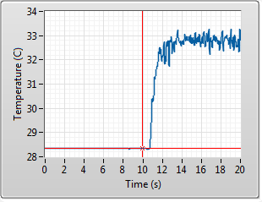

Figure 2-1: Typical thermistor response

2-2 While conducting this lab, you may have observed noise in the sensor output. To remedy this problem, the VI implements a software-based low-pass filter. A low-pass filter allows frequencies that are lower than a predefined cut-off to “pass”, while “blocking” or attenuating the remaining frequency information. This results in a “smoother” output signal. The downside of filtering is that it slows the response of the sensors. In this experiment, when you place your fingertip on the thermistor, your body acts as an antenna, attracting unwanted electromagnetic interference (EMI) from the environment. A common source of EMI includes AC power lines.

An alternative method of attenuating thermistor noise is to electrically insulate the sensor from touch. This can be achieved by covering the thermistor with a small piece of clear tape or cling wrap. Placing such barrier will electrically insulate the sensor from your fingertip, while allowing heat to be exchanged with the sensor.

Figure 2-2 contrasts the thermistor’s raw (unfiltered) output with the following cases: when LPF is switched on, and when the clear tape is placed on the sensor. The results indicate that placing a piece of clear tape on the sensor does a reasonably good job at filtering unwanted noise!

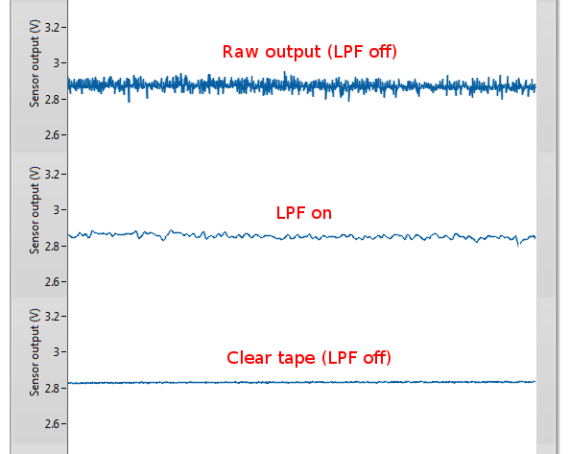

Figure 2-2: Thermistor raw and filtered responses

Your task is to observe the effectiveness of using a small piece of clear tape or cling wrap to attenuate thermistor noise. Record screenshots similar to those shown in Figure 2-2. Additionally, determine the thermal time constant of the thermistor when the clear tape is placed on the sensor (turn off the LPF during your investigation). Does your result indicate a slower responding thermistor?

# Lab 4: Strain Gage



Figure 0: Strain measurement is crucial in engineering design, as well as testing and maintenance practices

This lab explores the concept of strain measurement using a strain gage. The output of a strain gage mounted on a cantilever beam, placed in a quarter-bridge Wheatstone configuration, will be calibrated in terms of beam tip displacement. Furthermore, the natural frequency of the beam assembly will be measured by applying a fast Fourier transform to the response of the beam due to an impulse.

## Learning Objectives

After completing this lab, you should be able to complete the following activities:

* Understand the difference between quarter, half, and full Wheatstone bridge circuits
* Calibrate the output of a strain gage in terms of beam displacement
* Determine the natural frequency of a cantilever beam using a strain gage by applying a fast Fourier transform

## Required Tools and Technology

|  |  |
| --- | --- |
| Platform: NI ELVIS III | * View User Manual   http://www.ni.com/en-us/support/model.ni-elvis-iii.html |
| Hardware: Quanser Mechatronic Sensors Board | * View User Manual   http://www.ni.com/en-us/support/model.quanser-mechatronic-sensors-board-for-ni-elvis-iii.html |
| Software: LabVIEW Version 18.0 or Later  Toolkits and Modules:   * LabVIEW Real-Time Module * NI ELVIS III Toolkit | * Before downloading and installing software, refer to your professor or lab manager for information on your lab’s software licenses and infrastructure * Download & Install for NI ELVIS III * <http://www.ni.com/academic/download> * View Tutorials * http://www.ni.com/academic/students/learn-labview/ |
| AccessoriesFew small paper clips |  |

## Expected Deliverables

In this lab, you will collect the following deliverables:

* Record the zero offset of the bridge circuit
* Record the 5-point calibration data used to calibrate the strain gage
* Record the obtained calibration curve coefficients
* Screenshot of the calibration data showing the fitted curve
* Determine sensor sensitivity
* Determine the natural frequency of beam assembly
* Observe the relationship between mass and natural frequency

Your instructor may expect you to complete a lab report. Refer to your instructor for specific requirements or templates.

## Section 1: Measuring Strain

### 1.1 Theory and Background

#### What is Strain?

Strain is a measure of deformation in a solid body due to an applied force. Figure 1-1 illustrates a rectangular bar being subjected to an axial tensile stress ().

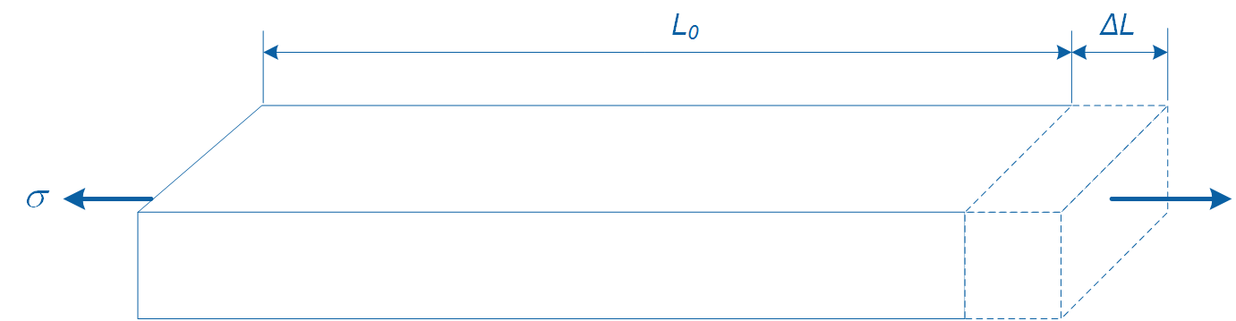

Figure 1-1: Change in length due to an axial tensile force

This stress causes a change in the original length of the bar from *L0* to *L0* + *L*. We define strain (**) using Equation 1-1:

Equation 1-1

$$ε=\frac{∆L}{L_{0}}$$

where *L0* is the original length and *L* is the change in length due to the applied force. Strain is dimensionless and expressed as a percentage (%) or in mm/mm. However, since strain values are typically very small, strain is expressed in micro-strain () by multiplying strain by 106.

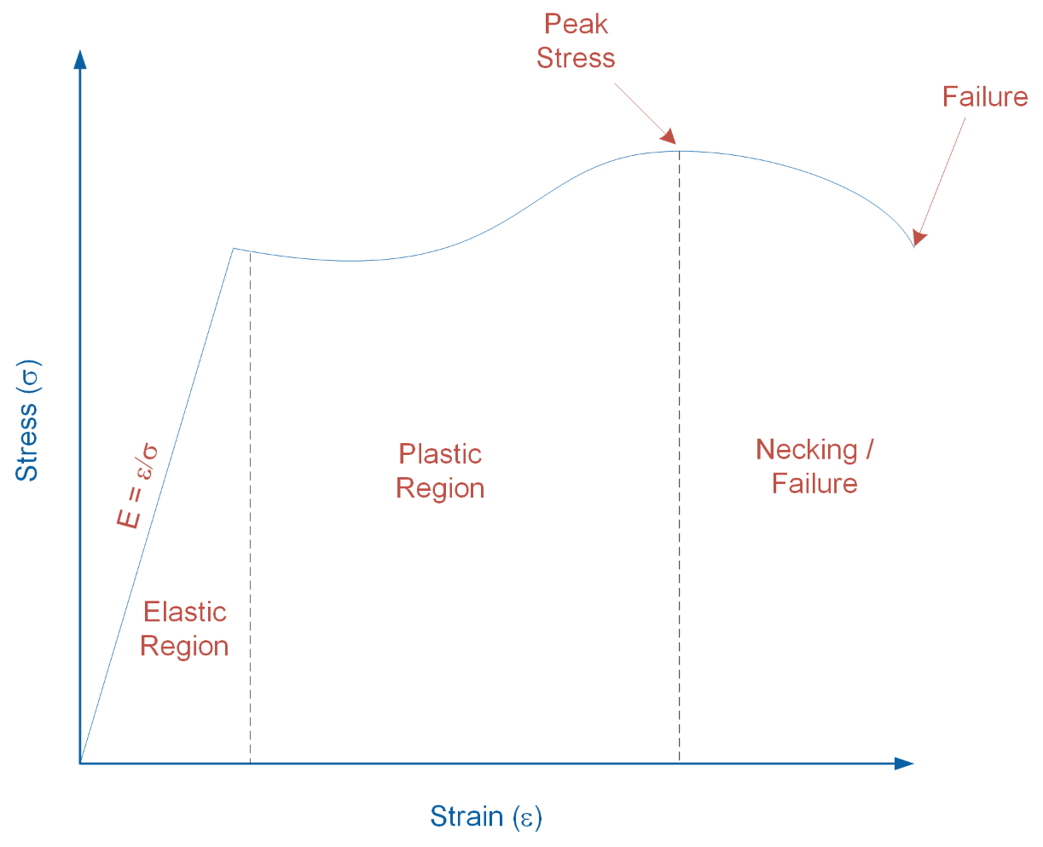

Figure 1-2: Stress-strain curve

Figure 1-2 illustrates the relationship between stress and strain when applied to a solid body. As shown in the graph, as stress increases, the solid body undergoes various deformation stages. In the elastic region, the body does not experience permanent physical change. In this region, the stress-strain relationship exhibits a linear relationship and we define the slope of the relationship as the modulus of elasticity (*E*=**) of the body. In the plastic region, the body permanently deforms, followed by the necking region where necking occurs prior to fracture.

#### Strain Gage

Strain gage is a sensor used for measuring strain in solid bodies. As shown in Figure 1-3, it is constructed from a fine metallic foil element formed into a grid pattern and mounted on a thin backing called a carrier. Strain gages are commonly bonded to test specimens using cyanoacrylate based adhesives or two-part epoxies. When an appropriate bond between the gage and specimen is established, any deformation in the specimen is transferred to the gage. This causes the resistance of the strain gage to change. When a strain gage is under tension its resistance increases, while under compression its resistance decreases.

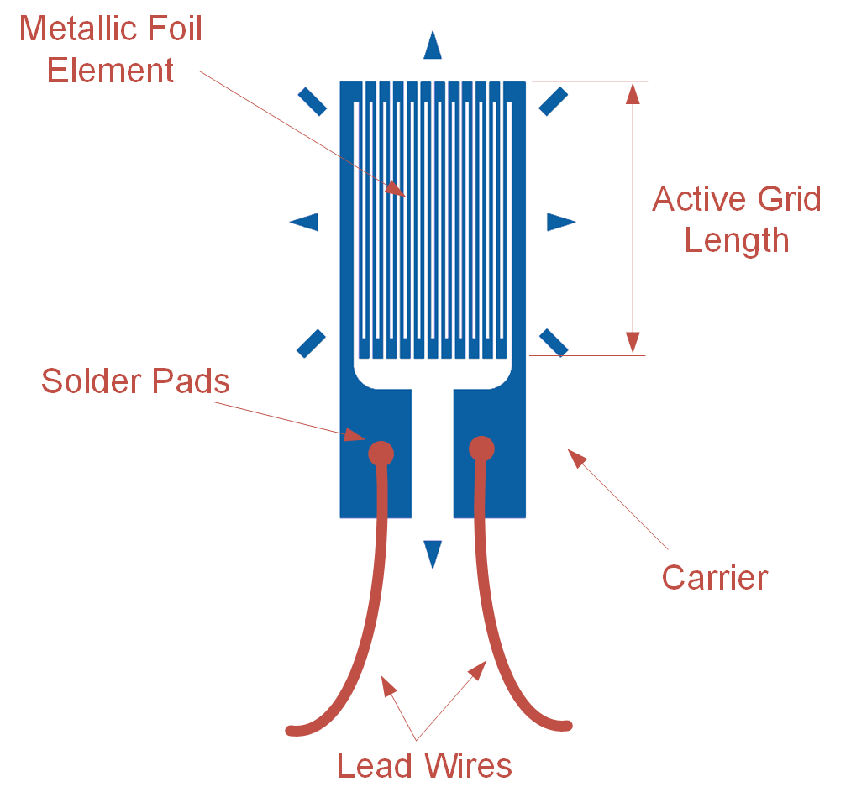

Figure 1-3: Schematic diagram of a strain gage

Strain gages vary in shape, orientation, and number depending on the type of strain being measured. The output of a strain gage is measured by connecting its lead wires to a dedicated signal conditioning circuit and DAQ, or dedicated strain measuring instrument.

Most strain gages have nominal resistances of 120 or 350 ohm. A higher nominal resistance and lower excitation voltage are desirable since that decreases measurement error due to lower Ohmic/self-heating effects.

The sensitivity to strain of a strain gage is called Gage Factor (GF) and is defined using Equation 1-2:

Equation 1-2

where *R* is the change in resistance when the strain gage is deformed, *RG* is the nominal resistance of the gage, and  is the induced strain. Typical gage factor values are approximately 2. For example, *GF* = 2 means if 1% strain is induced in a specimen, the gage’s relative resistance will change by 2%. Strain gages typically measure strains of up to 5% or 50,000 .

#### Wheatstone Bridge

The output of a strain gage is not directly measured; rather the voltage drop due to the change in the sensor’s resistance is measured using a Wheatstone bridge circuit (Figure 1-4). It offers several advantages over voltage dividing circuits, which are typically used for measuring the output of resistive sensors. One benefit is that a Wheatstone bridge allows for higher measurement sensitivity and lower measurement error. Another advantage is that it removes large fixed voltage drops which are present in a typical voltage dividing circuit. Since the output of Wheatstone bridge circuits is very low (typically in the range of microvolts), removing a large fixed voltage drop allows for the signal to be amplified using an amplifier.

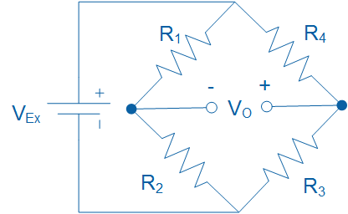

Figure 1-4: A Wheatstone bridge circuit for measuring the output of resistive sensors

The relationship between the resistors (*R1*, *R2*, *R3*, and *R4*), excitation voltage (*VEx*) and output voltage (*VO*) is governed by Equation 1-3:

Equation 1-3

$$V_{O}=\left(\frac{R_{3}}{R_{3}+R_{4}}-\frac{R_{2}}{R_{1}+R_{2}}\right)V_{Ex}$$

For *VO* to be zero, the following relationship must hold true, in which case the bridge is said to be balanced:

Equation 1-4

$$\frac{R_{1}}{R_{2}}=\frac{R_{4}}{R_{3}}$$

However, when the resistance of one of the resistors changes value, the bridge circuit generates an output voltage and is said to become unbalanced. Generally, the following three distinct Wheatstone bridge configurations are used for measuring the output of strain gages: (a) quarter-bridge, (b) half-bridge, and (c) full-bridge configuration.

##### Quarter-bridge Configuration

Figure 1-5 illustrates a quarter-bridge Wheatstone bridge configuration. It consists of a single active strain gage (*RG*) and three fixed external precision resistors. It is the simplest strain measurement configuration and offers the lowest measurement sensitivity. Typically *RG* = 120 or 350 ohm when unstrained and the fixed resistors each equal 120 or 350 ohm, respectively.

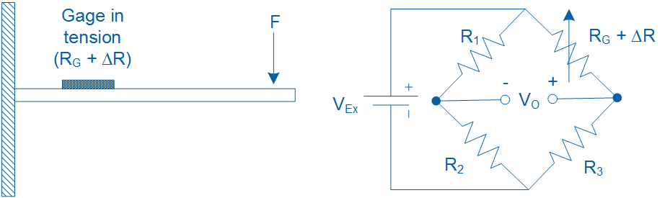

Figure 1-5: Quarter-bridge configuration for measuring strain in a cantilever beam

When a bending force is applied to the beam, it causes the beam along with the strain gage to deform. As a result, the resistance of the gage changes and a voltage output (*VO*) is generated which can be measured using a DAQ. The voltage output is proportional to the strain induced in the beam.

For example, assume that a bending force causes *RG*, which has a nominal resistance of 350 ohm, to increase by 0.0085 ohm. If the bridge is excited at 5 V, using Equation 1-3, the output voltage of the bridge circuit will be *V0* = -30 microvolts.

In practice, the output voltage of a quarter-bridge configuration is very minute and will require amplification to increase measurement resolution before being measured using a DAQ. Typical strain gage circuits or DAQs have built-in amplifiers to increase the signal levels to 10 mV/V (10 mV per each volt of excitation).

Assuming *R1* = *R2* = *R3* = *RG*, and substituting Eq. 1-2 in Eq. 1-3, the output voltage (*VO*) of the quarter-bridge circuit can be expressed in terms of *VEx*, *GF*, and the measured strain () as shown in Equation 1-5:

Equation 1-5

$$\frac{V_{O}}{V_{Ex}}=-\frac{GF∙ε}{4}\left(\frac{1}{1+GF∙\frac{ε}{2}}\right)$$

Note that the presence of the term 1/(1+GF∙/2) indicates non-linearity in the output of a quarter-bridge configuration with respect to strain.

##### Half-bridge Configuration

A half-bridge configuration uses two active strain gages and two fixed external resistors. Depending on the type of strain being measured (e.g. bending, torsion, tension, etc.), strain gages in a half-bridge configuration are mounted differently on a specimen. It offers the benefit of twice the sensitivity of a quarter-bridge configuration. Figure 1-6 illustrates a half-bridge configuration for measuring bending strain in a cantilever beam with two active gages mounted on opposite sides of the beam. When a bending force is applied to the beam, it causes tension in one of the gages while the other gage compresses.

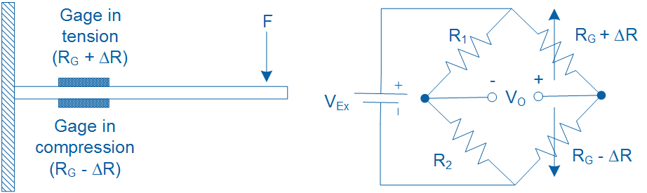

Figure 1-6: Half-bridge configuration for measuring strain in a cantilever beam

Assuming *R1* = *R2* = *RG*, and substituting Eq. 1-2 in Eq. 1-3, the output voltage (*VO*) of the half-bridge circuit can be expressed in terms of *VEx*, *GF*, and the measured strain () as shown in Equation 1-6:

Equation 1-6

$$\frac{V_{O}}{V_{Ex}}=-\frac{GF∙ε}{2}$$

##### Full-bridge Configuration

As illustrated in Figure 1-7, a full-bridge configuration uses 4 active strain gages of equal resistance (*RG*) and thus does not employ any external fixed resistors to complete the bridge circuit. Substituting Eq. 1-2 in Eq. 1-3, the output voltage of the full-bridge circuit (*VO*) can be expressed in terms of *VEx*, *GF*, and strain () as shown in Equation 1-7:

Equation 1-7

$$\frac{V_{O}}{V_{Ex}}=-GF∙ε$$

A full-bridge configuration produces twice the sensitivity of a half-bridge configuration and four times the sensitivity of a quarter-bridge configuration.

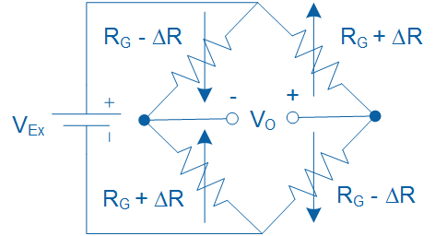

Figure 1-7: Full-bridge configuration for measuring strain

#### Effect of Temperature

In practice, change in temperature has a noticeable effect on the resistance of a strain gage, resulting in temperature induced strains. Such strains are caused by either self-heating of a strain gage, or due to differential thermal expansion between the strain gage and the specimen on which it is mounted.

Several practical methods exist to compensate for temperature-induced strain. One configuration, called quarter-bridge type II, uses one active gage and one dummy gage. This configuration is illustrated in Figure 1-8. The dummy gage is either mounted onto an identical unstrained secondary specimen which is placed in the proximity of the strained specimen, or it is mounted on the same specimen but in the transverse direction. Assuming *R1* = *R2* = *RG*, the output voltage (*VO*) of the quarter-bridge type II circuit can be expressed in terms of *VEx*, *GF*, and the measured strain () using Equation 1-5.

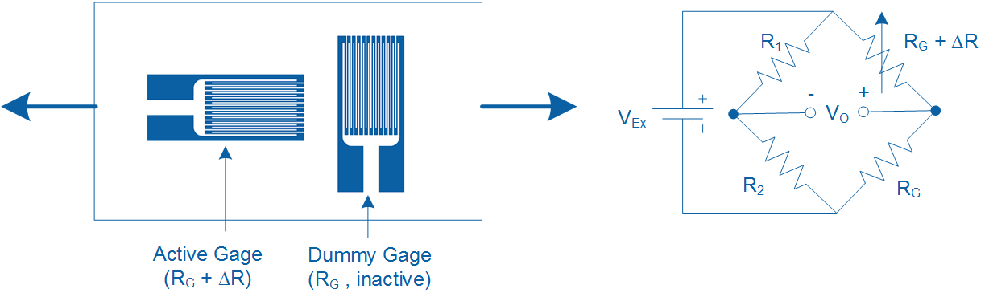

Figure 1-8: Quarter-bridge type II temperature compensating configuration

In this configuration, both the active and dummy gages experience the same fluctuations in temperature, with the resulting temperature induced strain canceling each other in the bridge configuration. Thus, any measured strain is due to active gage experiencing load-induced strain.

A more practical method of compensating for temperature-induced strain involves using a 3-wire self-temperature compensating strain gage. Such gages are made of alloys whose change in resistance due to temperature counters the change in resistance due to the differential thermal expansion between the gage and specimen. One of the limitations of such gages is that they should be mounted only on certain types of specimen.

#### Strain Gage Calibration

Strain gage calibration is the process of determining the mathematical relationship between the output of the Wheatstone bridge circuit versus the physical quantity being measured. Depending on the application the output of the bridge circuit may be calibrated to indicate strain (), deflection (mm), or mass (kg) by applying a series of known forces, displacements, or masses respectively. As part of the calibration process, the user must first adjust the *zero offset* and *full-scale span*.

Zero offsetting is the process of adjusting a Wheatstone bridge output to zero under no-load conditions. Such zero offsets exist because of normal tolerances in strain gage assemblies. This process, which establishes a reference point for measurement, is also referred to as null offsetting. Null offsetting is done using external resistors or via potentiometers built into the amplifier circuit of the strain measurement DAQ. Alternatively, zero offsetting can be achieved by means of software compensation rather than removing the offset off the bridge. However, if the offset is large enough, software compensation will limit the dynamic range of the measurement.

Full-scale span is the output range of a Wheatstone bridge circuit when the gage is subjected to maximum and minimum deflection. In practice, setting full-scale span requires the user to deflect the beam/gage assembly to its maximum or minimum positions and adjust the Wheatstone bridge output to a desired level using a gain potentiometer. Full-scale span is sometimes referred to as full-scale output (FSO) in sensor documentation.

Once zero offset and span have been adjusted, the user must apply three to five known inputs (e.g. deflection or load) to the specimen/strain gage assembly, and record the corresponding output of the bridge circuit. A calibration equation is then obtained by fitting a line to the measured points. Once the calibration equation is determined, it can be used to calculate the calibrated physical quantity for any given output of the bridge circuit.

### 1.2 Implement

The Virtual Instrument (VI) used to collect data from and calibrate the strain gage is shown in Figure 1-9.

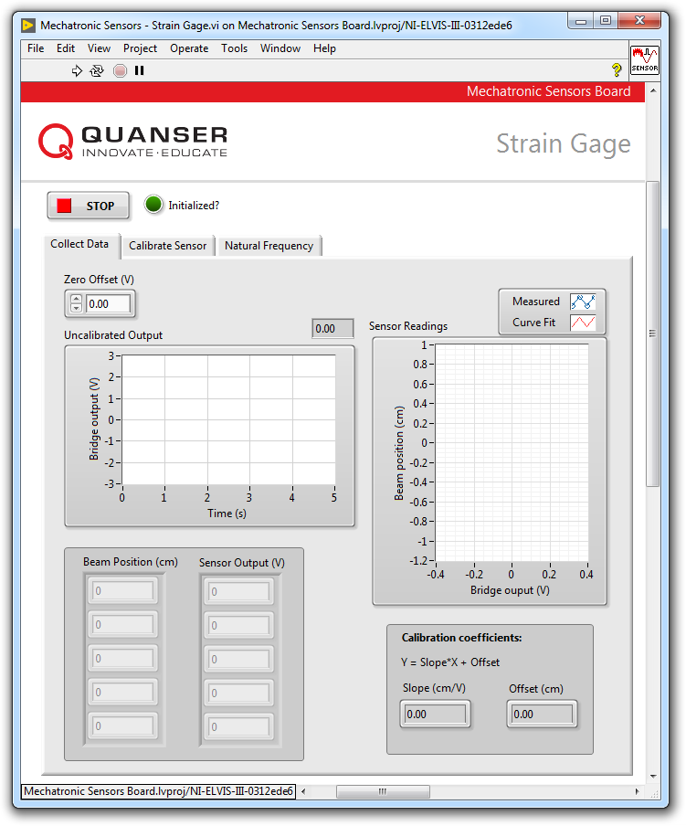

Figure1-9: VI for collecting data from the strain gage

#### Collect Data

1. Open **Mechatronic Sensors Board.lvproj**
2. From the **Project Explorer** window, open **Mechatronic Sensors – Strain Gage.vi**
3. Click on the **Collect Data** tab.
4. Run the VI.
5. Wait for the **Initialized?** LED indicator to turn on.
6. Using the **Uncalibrated Output** waveform chart, read the initial strain gage bridge output.
7. Balance the output of the strain gage bridge. To do this, make sure position and hold the tip of the cantilever beam at the 0 cm mark. Adjust the **Zero Offset (V)** numeric control such that the uncalibrated output of the bridge circuit is as close as possible to 0.00 V. Record the zero offset value in Table 1-1.
8. Enter -1 in the **Beam Position (cm)** array.
9. Flex the tip of the cantilever beam to the -1 cm mark.
10. Read the corresponding strain gage output and enter the value in the **Sensor Output (V)** array.
11. Repeat the process by moving the tip of the beam to the following positions: -0.5 cm, 0 cm, +0.5 cm and +1 cm. Each time, enter the beam position and measured sensor outputs in the **Beam Position (cm)** and **Sensor Output (V)** arrays respectively.
12. Once the measured readings are entered, a linear curve is automatically generated to fit the data. The curve is shown in the **Sensor Readings** waveform graph. This curve represents the calibration curve of the sensor. Take a screenshot of the graph.
13. The slope and offset of the calibration curve are automatically calculated by the VI and displayed in the **Slope (cm/V)** and **Offset (cm)** indicators. Make a note of these values in Table 1-2.
14. Record the collected data in Table 1-3.
15. Take a screenshot of the **Sensor Readings** graph.
16. Continue to the next section.

Table 1-1: Recorded bridge zero offset

|  |  |
| --- | --- |
| Zero offset (V) |  |

Table1-2: Calibration coefficients

|  |  |
| --- | --- |
| Slope (cm/V) | Offset (cm) |
|  |  |

Table 1-3: Recorded bridge output

|  |  |
| --- | --- |
| Beam Position (cm) | Bridge Output (V) |
| -1.0 |  |
| -0.5 |  |
| 0.0 |  |
| +0.5 |  |
| +1.0 |  |

#### Calibrate the Strain Gage

1. Click on the **Calibrate Sensor** tab to calibrate the output of the strain gage bridge circuit in terms of linear displacement of the tip of the cantilever beam (in cm).
2. Use the **Slope (cm/V)** and **Offset (cm)** numeric controls to enter the slope and offset values you obtained during the data collection step.
3. Test the accuracy of your calibration. To do this, flex the cantilever beam to different positions and verify that the correct position is displayed in the **Calibrated Output** waveform chart as well as the **Beam Position (cm)** slider indicator.
4. Press the **Stop** button.

### 1.3 Analyze

1-1 What is the initial bridge zero offset that you recorded in Table 1-1?

1-2 Present the calibration coefficients that you recorded in Table 1-2.

1-3 Present the calibration data you recorded in Table 1-3.

1-4 Attach a screenshot of the Sensor Readings waveform graph showing the fitted calibration curve from step 12.

1-5 What calibration equation did you obtain?

1-6 What is the sensitivity of the amplified bridge circuit in V/cm?

1-7 How well did your calibrated output match the actual beam tip position in step 19?

1-8 Based on the data you collected in Table 1-1, use Equation 1-5 in to determine the maximum and minimum strains induced in the cantilever beam as it’s flexed between -1 cm and +1 cm. For each case, determine if the strain gage is under tension (or compression). Assume a gage factor of GF = 2, a bridge excitation voltage of VEx = +5 V, and an amplification gain of 100.

*Hint:* The output of the bridge circuit is amplified prior to being displayed in the VI. All calculations done using Equation 1-5 must be done using actual (i.e. pre-amplified) bridge output values.

## Section 2: Design Considerations

2-1 A strain gage can be used to indirectly measure other physical quantities such as vibration. Accurate measurement of vibration is imperative in ensuring the health of electro-mechanical systems. For example, excessive vibration can cause fractures in the fuselage of an airplane, or cause solder joints to break free in electronic circuit boards. Strain-based vibration switches are commonly used as a simple protection device that senses vibration and triggers an alarm or shuts down a machine if vibration exceeds a certain threshold.

The strain gage mounted on the cantilever beam in the Mechatronic Sensors Board can be used to determine the natural frequency of the beam assembly. Natural frequency is a property of an object that quantifies the frequency at which it “wants” to naturally vibrate when subjected to a disturbance. If a system has a natural frequency that matches normal environmental vibration, then the system will vibrate more violently and may prematurely fail.

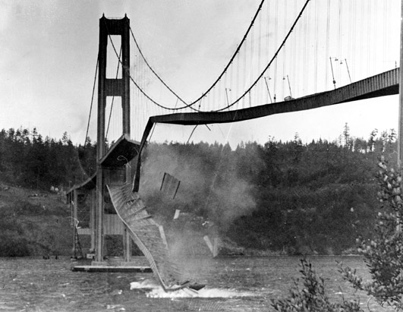  
A structure may fail if its natural frequency matches environmental vibration

Determine the natural frequency of the beam assembly by following the steps below:

* Run the VI.
* Click on the **Natural Frequency** tab.
* Ensure the beam is at rest (i.e. not vibrating).
* With one finger gently bend and then release the tip of the beam.
* Wait for a couple of seconds for the beam to stop vibrating then promptly press the **Stop** button.
* The VI will apply a fast Fourier transform to the captured data and display the result in the **Power Spectrum** waveform graph. The response should look similar to the figure below.
* Using the **Cursor** tool, measure the peak frequency.

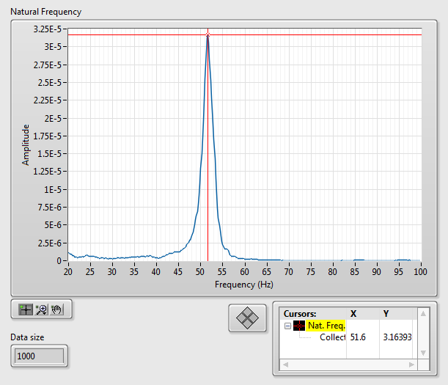

Sample natural frequency response

2-2 Natural frequency of a cantilever beam can be calculated using the following equation:

$$f_{n}=\frac{1}{2π}\sqrt{\frac{k}{m}}$$

where *fn* is natural frequency in Hz, *k* is stiffness of the beam in N/m, and *m* is the mass of the beam in kg. The equation indicates that natural frequency has an inverse relationship with the square root of mass. Validate this relationship by attaching a small paper clip to the tip of the cantilever beam and measuring the natural frequency of the modified beam. Does increasing the beam mass decrease its natural frequency?

# Lab 5: Pressure

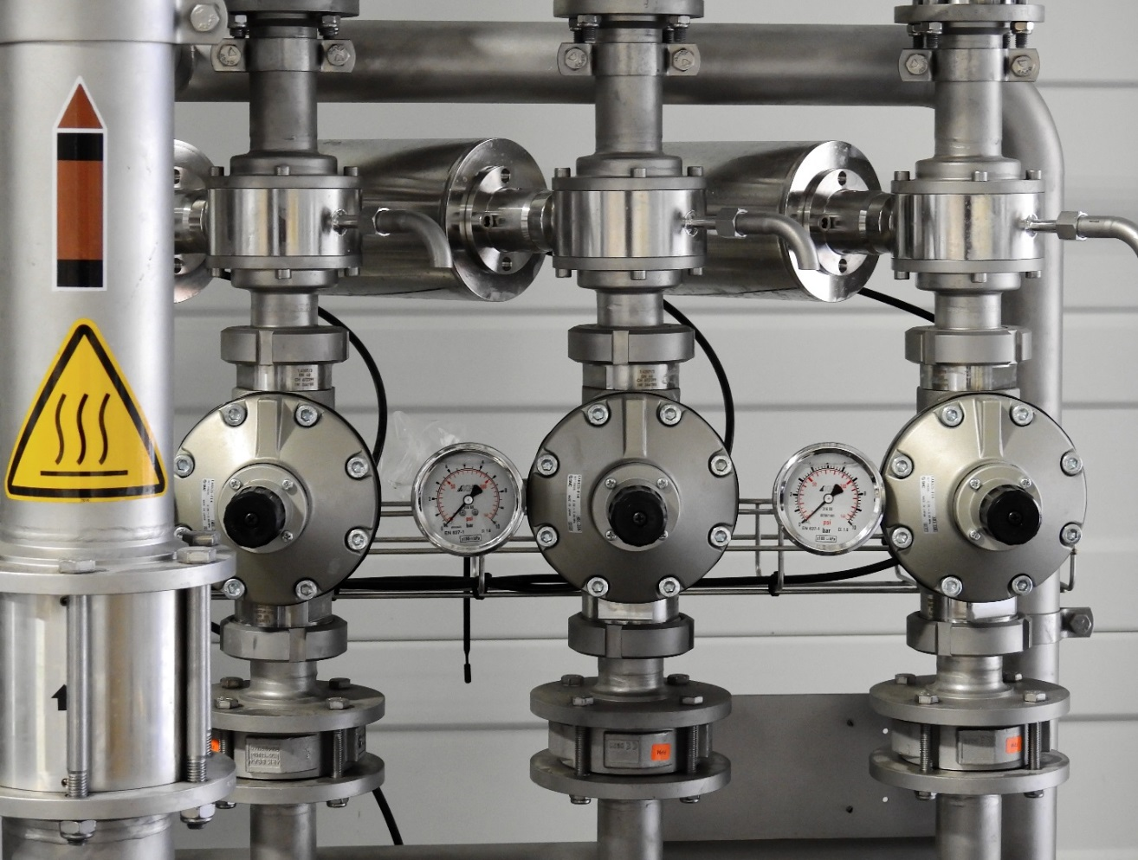

Hình 0: Các phép đo áp suất là rất cần thiết trong các hệ thống tự động hóa công nghiệp

Bài thí nghiệm này khám phá các phép đo áp suất sử dụng một đầu dò áp suất kiểu điện dung. Các điểm tham chiếu được dựa trên định luật Boyle sẽ được thiết lập trước khi hiệu chỉnh các đầu dò. Cả áp suất tuyệt đối và áp suất đo sẽ đều được lấy.

## Các mục tiêu nghiên cứu

Sau khi hoàn thành bài nghiên cứu này, sinh viên nên hoàn thành các hoạt động sau đây:

* Thiết lập các điểm đo tham chiếu để hiệu chuẩn dựa trên định luật Boyle
* Thực hiện phép hiệu chuẩn 5 điểm liên tiếp
* So sánh các đường cong hiệu chuẩn tỷ lệ trên và tỷ lệ dưới
* Đo áp suất sử dụng cả hai thang đo áp suất tuyệt đối và thang đo áp suất đo

## Công nghệ và các công cụ yêu cầu

|  |  |
| --- | --- |
| Platform: NI ELVIS III | * Xem hướng dẫn người dùng   http://www.ni.com/en-us/support/model.ni-elvis-iii.html |
| Phần cứng: Mạch Quanser Mechatronic Sensors | * Xem hướng dẫn người dùng   http://www.ni.com/en-us/support/model.quanser-mechatronic-sensors-board-for-ni-elvis-iii.html |
| Phần mềm: LabVIEW Phiên bản 18.0 hoặc hơn  Toolkits Và Modules:   * LabVIEW Real-Time Module * NI ELVIS III Toolkit | * Trước khi tải xuống và cài đặt phần mềm, tham khảo chuyên gia hoặc người quản lý phòng thí nghiệm về giấy phép phần mềm của phòng nghiên cứu * Tài xuống và cài đặt NI ELVIS III * <http://www.ni.com/academic/download> * Xem hướng dẫn * http://www.ni.com/academic/students/learn-labview/ |

## Các yêu cầu cần đạt được

Trong bài thí nghiệm này, sinh viên cần đạt được các yêu cầu sau:

* Xác định áp suất không khí phù hợp với độ cao
* Tính toán và ghi lại các điểm áp suất tham chiếu sử dụng ống đo bằng cách áp dụng định luật Boyle
* Ghi lại dữ liệu hiệu chuẩn (theo hướng tỷ lệ lên và xuống)
* Chụp màn hình các đồ thị hiệu chuẩn mà chỉ ra các đường cong phù hợp
* Ghi lại các hệ số hiệu chuẩn (theo hướng tỷ lệ lên và xuống)
* Ghi lại các giá trị áp suất đo và tuyệt đối lớn nhất và nhỏ nhất được tạo ra
* Tính toán độ nhảy cảm biến theo V/kPa
* Tính toán điện dung lý thuyết với các thông số cảm biến đã cho
* So sánh hiệu chuẩn cảm biển đạt được với hiệu chuẩn của nhà sản xuất

Người hướng dẫn sẽ giúp sinh viên hoàn thành bài báo cáo thí nghiệm. Tham khảo người hướng dẫn các yêu cầu cụ thể

## Phần 1: Đo lường và hiệu chuẩn áp suất

### 1.1 Lý thuyết

#### Áp suất là gì?

Áp suất là độ lớn của lựa trên một đơn vị diện tích được định nghĩa ở phương trình 1-1:

Phương trình 1-1

$$p=\frac{F}{A}$$

Có nhiều đơn vị được sử dụng để thể hiện áp suất. Đơn vị SI của áp suất là pascal (Pa), tương đương với newtons trên một đơn vị diện tích (N/m2). Các đơn vị phổ biến khác bao gồm pounds trên một đơn vị diện tích inch (psi), bar và atmosphere (atm). Áp suất tại mực nước biển dưới các điều kiện không khí chuẩn tương đương với *patm* = 1 atm và bằng 101.32 kPa.

Áp suất được đo sử dụng 2 thang đo khác nhau: đo hoặc tuyệt đối. Áp suất đo (*pgage*) là áp suất tương ứng với áp suất khí quyển địa phương (*p0*), trong khi áp suất tuyệt đối (*pabs*) là áp suất tương ứng với chân không hoàn hảo. Mối quan hệ giữa áp suất tuyệt đối và tương đối được cho bởi phương trình 1-2 và minh họa ở hình 1-1

Phương trình 1-2

$$p_{gage}=p_{abs}-p_{0}$$

Chú ý rằng giá trị của *p0* phụ thuộc vào điều kiện địa lý và khí quyển, và có thể có hoặc không cao hơn áp suất khí quyển theo chuẩn.

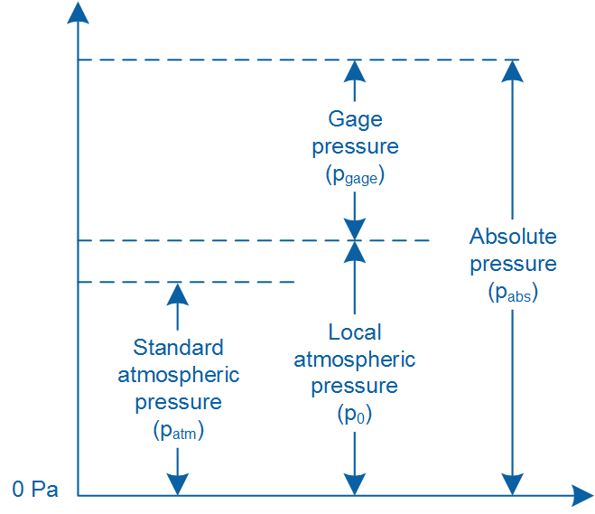

Hình 1-1: So sánh giữa các thang đo áp suất

#### Định luật Boyle

Định luật Boyle phát biểu rằng tích của thể tích và áp suất của một khí gas bị nén là hằng số. Nó được thể hiện qua phương trình:

Phương trình 1-3

$$pV=k$$

ở đó p là áp suất của khí, V là thể tích của khí và k là hằng số. Một dạng khác của định luật Boyle thường được sử dụng để so sánh một khí dưới 2 điều khiện khác nhau, được biểu diễn bởi:

Phương trình 1-4

ở đó *p1* và *V1* là áp suất và thể tích của kí dưới điều kiện 1, và *p2* và *V2* áp suất và thể tích của khí dưới điều kiện 2. Hình 1-2 minh họa định luật Boyle sử dụng một bể áp suất. Trong ví dụ này, khi bít tông của ống bơ được ép xuống bể, áp suất của khí tăng từ trạng thái ban đầu của nó là *p1* to *p2*, trong khi thể tích của khí giảm từ *V1* xuống *V2*.

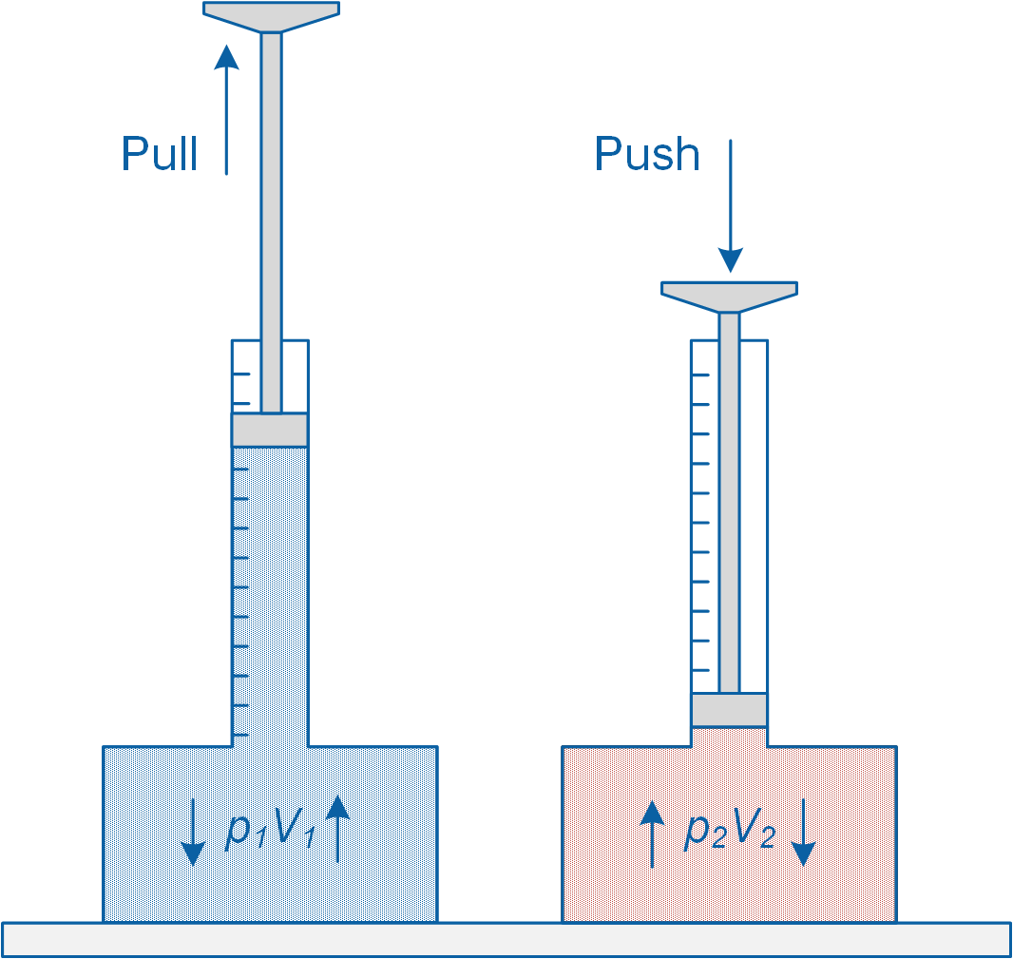

Figure1-2: Demonstration of Boyle’s law

#### Đầu dò áp suất

Các đầu dò áp suất được sử dụng trong các ứng dụng cơ điện tử hiện đại dùng để đo áp suất đo, áp suất tuyệt đối và áp suất vi phân. Chúng là các thiết bị cơ điện có đầu ra là một tín hiệu điện tỷ lệ với áp suất đo được. Một đầu dò áp suất có một mảng ngăn hoặc màng mỏng mà sẽ uốn cong theo áp suất tác dụng

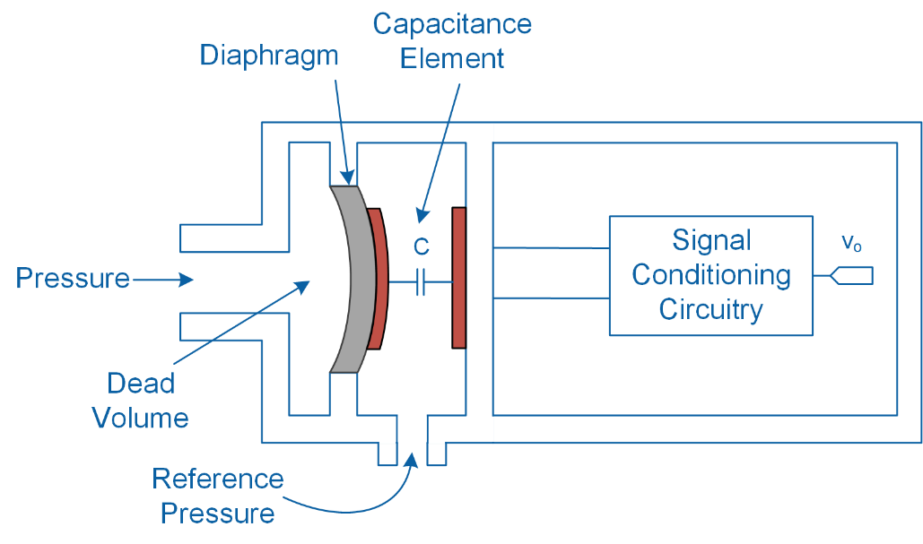

(a) Capacitive type

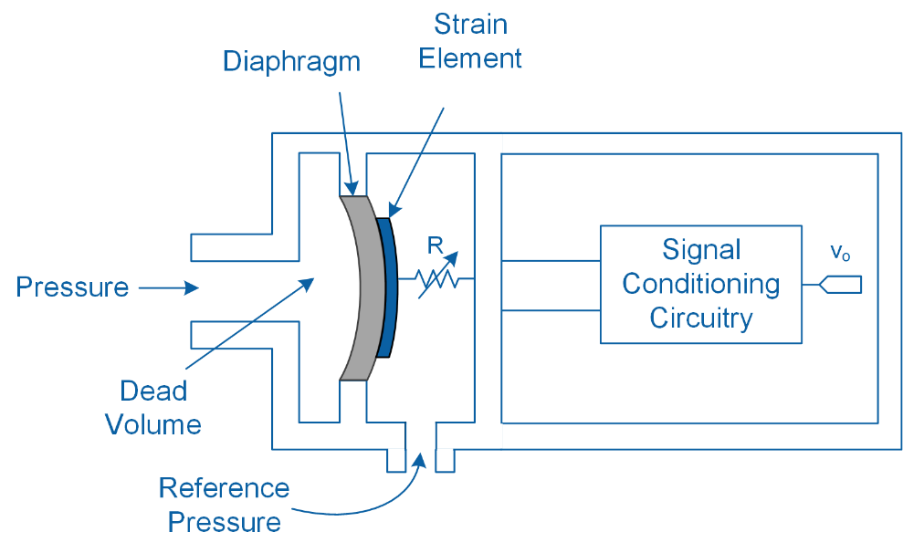

(b) Resistive type

Figure1-3: Sơ đồ mạch minh hoạt của hai loại đầu dò áp suất phổ biến

Như hình minh họa theo sơ đồ mạch ở hình 1-3, một đầu dò áp suất chứa một phần tử biến đổi hoặc một tụ điện gắn với màng ngăn, khi có áp suất tác động vào sẽ tạo ra thay đổi trong điện trở hoặc điện dung của phần tử cảm biến. Sự biến thiên trong phần tử cảm biển sau đó sẽ được chuyển thành một tín hiệu điện có thể xác định sử dụng mạch điều hòa tín hiệu.

Các đầu dò áp suất thường có đáp ứng nhanh và cho phép các phép đo chính xác. Tuy nhiên, bởi vì các thiết bị điện tử cấu tạo bên trong nên chúng cần cấp nguồn điện để có thể hoạt động

Như được minh hoạt ở hình 1-3, một đầu dò áp suất sẽ kết hợp với một cổng áp suất tham chiếu bên trong. Khi đo áp suất đo, cổng được đưa ra áp suất khí quyển. Tuy nhiên, khi đo áp suất tuyệt đối, cổng được đóng lại để các phép đo được tham chiếu với các khoảng chân không tuyệt đối. Trong phép đo áp suất vi phân, phần chính và các cổng áp suất tham chiếu được đưa tới hai nguồn áp suất khác nhau.

#### Hiệu chỉnh đầu dò áp suất

Một cách thuận tiện để chuyển đầu ra của một đầu dò áp suất thành một đơn vị áp suất là sử dụng độ nhạy được công bố của nhà sản xuất và các giá trị bù cho đầu dò. Độ nhạy của một đầu dò áp suất liên quan tới đầu ra cả áp suất đo được sẽ được cho dưới dạng volt trên một đơn vị áp suất.

Thay vào đó, một phép kiểm tra hiệu chỉnh liên tiếp có thể được dùng. Ta sẽ dùng ột chuỗi liên tiếp các áp suất đã biết trước cho một đầu dò và ghi lại đầu ra tương ứng. Việc hiệu chuẩn có thể được hoàn thành bằng cách tăng áp suất đầu vào (tỷ lệ tăng) hoặc giảm áp suất đầu vào (tỷ lệ xuống).

Mối quan hệ giữa đầu ra và đầu vào của cảm biển được tính toán dựa trên phương trình phù hợp với dữ liệu ghi được. Sử dụng phương trình hiệu chỉnh, các áp suất chưa biết có tể được xác định với một đầu ra bất kì.

Table 1-1: Các kết quả của phép hiệu chuẩn 5 điểm

|  |  |
| --- | --- |
| Áp suất (psi) | Đầu ra (V) |
| 0.0 | 0.100 |
| 5.0 | 1.255 |
| 10.0 | 2.550 |
| 15.0 | 3.505 |
| 20.0 | 4.950 |

Bảng 1-1 là kết quả của phép hiệu chỉnh 5 điểm theo hướng tỷ lệ tăng. Phương trình hiệu chuẩn của cảm biến ở hình 1-4 được thiết lập để phù hợp với các điểm

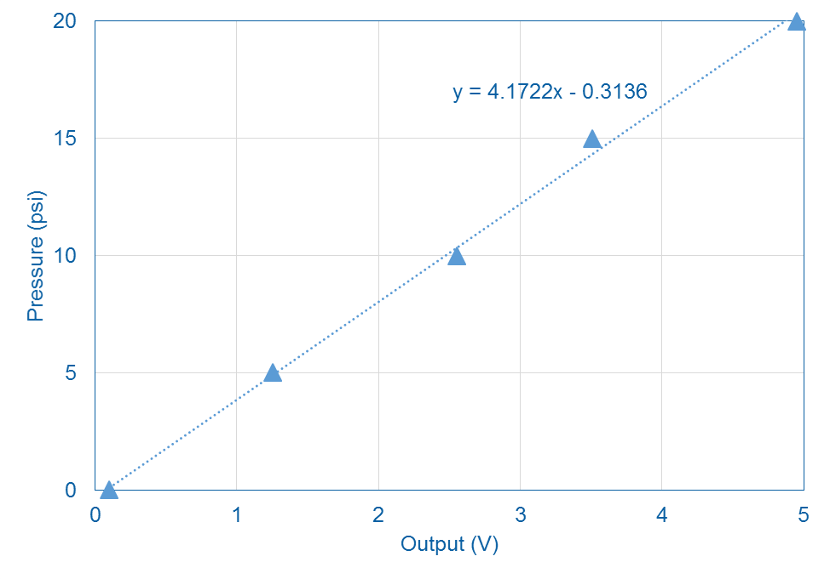

Figure 1-4: Đường thảng tương ứng với dữ liệu ghi được

### 1.2 Triển khai

Hình 1-5 miêu tả việc sử dụng Dụng cụ ảo (*Virtual Instrument - VI*) để thu thập dữ liệu và hiệu chỉnh đầu đo áp suất.

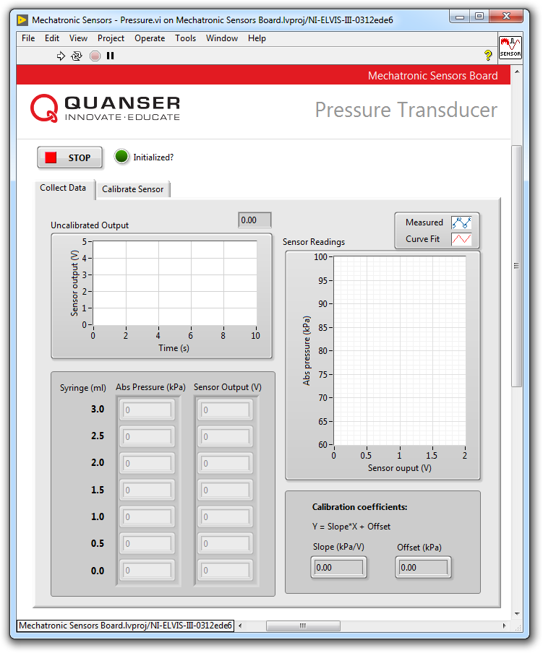

Figure1-5: VI cho dã liệu thu được từ đầu dò áp suấy

#### Thiết lập điểm tham chiếu

1. Xác định áp xuất cục bộ (kPa) xử dụng áp suất kế hoặc lấy thông tin áp xuất từ trạm thời tiết gần nhất từ mạng internet. Nếu như không thể lấy được giá trị áp suất bằng 2 cách trên, lấy giá trị áp suất cục bộ trung bình là 101.3kPa.  
     
   Các trạm thời thiết thường đưa ra báo cáo đo đạc đã được đưa về chuẩn tại mực nước biển (điều kiện độ cao 0m và nhiệt độ môi trường xung quanh ở 15°C). Trong trường hợp đó ta phải tính lại áp suất tại điểm của chúng ta dựa vào độ cao và nhiệt độ hiện tại. Ta có công thức tính toán như sau: (Công thức 1-5)

Equation 1-5

$$p_{local}=p_{sea}{\left(1-\frac{0.0065h}{T+273.15+0.0065h}\right)}^{5.257}$$

trong đó $p_{sea}$ là áp suất (kPa) lấy được từ trạm thời tiết, *h* là độ cao (m) của điểm ta cần tham chiếu, *T* là nhiệt độ (°C) tại điểm tham chiếu và $p_{local}$ là áp suất (kPa) hiện tại.

1. Trong phân tiếp theo, bạn sẽ lần lượt cho đầu dò vào các áp suất đã biết sử dụng xi-lanh. Đầu tiên, ta sẽ bắt đầu tại áp suất khí quyển với mức chỉ thị xi-lanh ở mốc 3ml. Sau đó ta tăng dần áp suất lên bằng cách hạ chỉ thị xuống.

Sử dụng áp suất vừa tính được ở phần trên cùng với công thức 1-3 và 1-4, tính toán áp suất khi xi-lanh ở các mức 3.0, 2.5, 2.0, 1.5, 1.0, 0.5 và 0.0ml. Chú ý rằng buồng áp suất có thể tích 5ml, chưa kể đến thể tích của xi-lanh. Ghi lại kết quả vào bảng 1-2.

1. Điền bảng và tiếp tục đến phần tiếp theo

Table1-2: Các áp suất tham chiếu sử dụng ống

|  |  |
| --- | --- |
| Syringe (ml) | Absolute Pressure (kPa) |
| 3.0 |  |
| 2.5 |  |
| 2.0 |  |
| 1.5 |  |
| 1.0 |  |
| 0.5 |  |
| 0.0 |  |

#### Thu thập dữ liệu

1. Mở file **Mechatronic Sensors Board.lvproj**
2. Trong cửa sổ **Project Explorer**, mở file **Mechatronic Sensors – Pressure.vi**
3. Nhấn vào **Collect Data.**
4. Chạy dụng cụ ảo (*VI*).
5. Chờ cho đèn LED **Initialized?** (báo khởi tạo bắt đầu) bật lên.
6. Nếu xi-lanh đã được gắn thì tháo xi-lanh khỏi buồng áp suất.
7. Đưa xi-lanh tới vị trí 3ml.
8. Nếu có, tháo bỏ nắp bảo vệ của buồng cảm biến áp suất.
9. Gắn xi-lanh vào khóa kết nối Luer trên buồng cảm biến áp suất bằng cách xoay nhẹ xi-lanh theo chiều kim đồng hồ. Cần chắc chắn rằng xi-lanh đã được kết nối. Áp suất trong bình bây giờ cân bằng với áp suất khí quyển. Chú ý gắn xi-lanh sao cho phần độ đo của xi-lanh hướng ra phía trước.
10. Nhận giá trị đầu tiên của bảng 1-1 vào dãy **Abs – Pressure (kPa)** trên bảng giao diện của *VI*. Sử dụng biểu dồ dạng sóng **Uncalibrated Output**, đọc giá trị xuất ra từ cảm biến và nhập giá trị vào dãy **Sensor Output (V)**.
11. Tiếp tục thực hiện như thế với các bước đặt xi-lanh cách nhau 0.5ml. Lần lượt điều giá trị của áp suất (từ bảng 1-1) cùng với giá trị **Abs – Pressure (kPa)** và **Sensor Output (V)** tương ứng.

*Chú ý:* Khi tất cả các số liệu đã được nhập, một đồ thị cong sẽ được tự động vẽ dựa trên dữ liệu đã nhập. Đồ thị này nằm trong mục đồ thị sóng **Sensor Readings**. Đường cong này thể hiện đường cong chuẩn hóa của cảm biến.

1. Điền các dữ liệu vào bảng 1-3.

1. Hệ số góc và giá trị offset của đường con hiệu chỉnh được tự động tính toán bởi *VI* ở mục **Slope (kPa/V)** và **Offset (kPa)**. Ghi lại hai giá trị này ở bảng 1-4.
2. Chụp màn hình đồ thị Sensor Readings.
3. Điền bảng và tiếp tục đến phần tiếp theo.

Table1-3: Dữ liệu hiểu chuẩn được ghi lại

|  |  |  |
| --- | --- | --- |
| Syringe (ml) | Absolute Pressure (kPa) | Output (V) |
| 3.0 |  |  |
| 2.5 |  |  |
| 2.0 |  |  |
| 1.5 |  |  |
| 1.0 |  |  |
| 0.5 |  |  |
| 0.0 |  |  |

Table1-4: Hệ số hiệu chuẩn

|  |  |
| --- | --- |
| Slope (kPa/V) | Offset (kPa) |
|  |  |

#### Hiệu chuẩn đầu dò áp suất

1. Ấn vào tab **Calibrate Sensor** để hiệu chỉnh đầu ra của đầu dò áp suất (kPa).
2. Sử dụng phần kiếm soát số **Atmospheric Pressure (kPa)** và nhập giá trị áp suất đã tính toán ở bước 1.
3. Sử dụng phần kiểm soát số **Slope (kPa/V)** và **Offset (kPa)** và nhập giá trị đã lấy được ở bước lấy dữ kiện trên.
4. Di chuyển vị trí của xi-lanh và quan sát giá trị hiển thị trong đồ thị **Calibrated Output** và các thanh chỉ thị **Absolute, Gage**. Sự khác biệt giữa giá trị absolute và gage?
5. Giá trị tối đa của áp suất absolute và gage (kPa) mà ta có thể tạo ra?
6. Có thể tại ra áp suất âm bằng xi-lanh không? Giá trị tối thiểu của áp suất absolute và gage (kPa) mà ta có thể tạo ra?
7. Ấn nút **Stop**.

### 1.3 Phân tích

1-1 Giá trị của áp suất cục bộ (kPa)? Giá trị đã hiệu chỉnh độ cao và nhiệt độ? Trình bày cách tính.

1-2 Trình bày điểm tham chiếu ghi nhận được ở bảng 1-2. Trình bày ví dụ cách tính.

1-3 Trình bày dữ liệu hiệu chỉnh đã ghi nhận được ở bảng 1-3.

1-4 Trình bày hệ số hiệu chuẩn đã ghi nhận được ở bảng 1-4.

1-5 Đính kèm ảnh chụp màn hình của dạng đồ thị đường cong hiệu chuẩn.

1-6 Phương trình hiệu chuẩn thu được?

1-7 Làm thế nào để tạo ra giá trị áp suất gage âm bằng xi-lanh.

1-8 Giá trị cực đại và cực tiểu của absolue và gage có thể tạo ra?

1-9 Độ nhạy của cảm biến (V/kPa)?

## Phần 2: Các cân nhắc trong thiết kế

2-1 Ta đã có được đồ thị hiệu chuẩn cho đầu dò áp suất bằng cách đối chiếu liên tục khi tăng áp suất lên. Khi thiết kế hệ thống cơ điện tử, ta thương gặp phải câu hỏi: Liệu ta có thể dùng phương trình hiệu chuẩn để tính toán giá trị bên ngoài khoảng đo đã giới hạn? Nói cách khác, có thể dùng phương trình hiệu chuẩn để ngoại suy ra ngoài khoảng hiệu chuẩn?

Hãy nghiệm từng phần của câu hỏi này bằng cách thực hiện lại thí nghiệm trên nhưng hiệu chỉnh đầu dò áp suất bằng giá trị gage âm (thanh dưới). Đồ thị ở thang dưới khác gì so với đồ thị ta đã thu được trước đó? Thang đo hiệu chuẩn trên có thể được ngoại suy ra thang dưới?

2-2 Mạch hệ thống cảm biến cơ điện tử sử dụng cảm biến áp suất Infineon KP236N6165. Nhà sản xuất đã cung cấp công thức hiệu chuẩn của điện áp đầu ra cảm biến như sau:

$$V_{out}=V_{DD}\left(a×P+b\right)$$

trong đó $V_{DD}$ = 5V, a = 0.00876 ($kPa^{-1}$) và b = -0.48571.

Công thức trên áp dụng trong khoảng đo từ 60 đến 150 kPa. Phương trình của nhà sản xuất khác biệt như thế nào với phương trình ta vừa tính toán. Đo áp suất khí quyển bằng cả 2 phương trình, chúng khác nhau như thế nào? Hãy đưa ra nhận xét về một số nguồn sinh ra lỗi trong phép đo. Nhà sản suất đưa ra sai số chính xác là $±$ 1.0kPa khi nhiệt độ trong khoảng 0 – 85 °C.

2-3Như đã nêu trong phần Lý thuyết và Nền tảng, tụ cảm biến áp suất suất gồm 2 bản tụ song song được nối với một tấm màng. Khi cảm biến tiếp xúc với các nhiệt độ khác nhau, tấm màng ngắn này sẽ co giãn và từ đó điện dung của tụ điện thay đổi theo. Điện dung được xác định bằng công thức sau đây:

$$C=\frac{cεA}{d}$$

Trong đó d là khoảng cách giữa 2 bản cực, A là diện tích hình chiếu của 2 bản cực lên bề mặt của nhau, $ε$ là hằng số tỉ lệ (=8.85. ${10}^{-15}$ F/mm với đơn vị diện tích là $mm^{2}$ và khoảng cách là mm), và c là hằng số chất điện môi của vật liệu nằm giữa 2 bản cực.

Giả sử như bạn đang thiết kế một đầu dò tụ, hãy tính toán sơ bộ giá trị điện dung theo lý thuyết nếu A = 1 $mm^{2}$, d = 500 $μm$, và c = 1.